Explanation
First case :
This use case is ok...
There are datas in all cells
List in standard filter have all background color 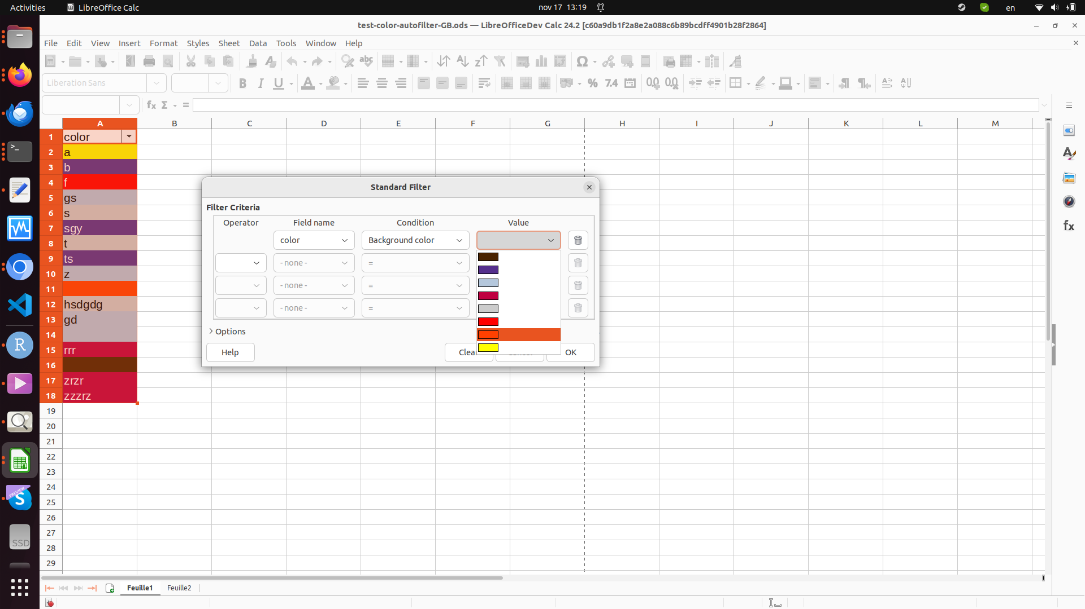

Second case !

Now use case with no datas in cell, only background color
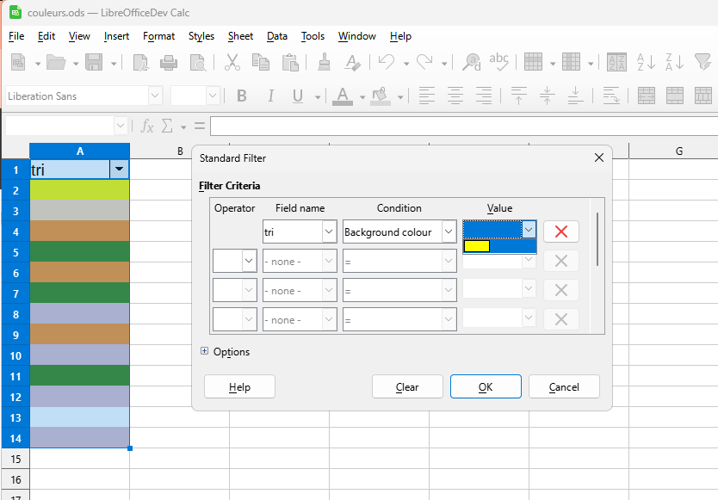
- we can see that the list is reduced to one colour.
- we expect to have all colour in this case as use case 1 shows it.

