List interface problems
Here is description of 3 problems with interface of lists in Writer.

Example text on russian:
- Все вкладки, расположенные между этими двумя листами, станут белыми. Теперь любые действия, которые вы выполняете, будут применяться ко всем выделенным листам.
and screenshot of it:
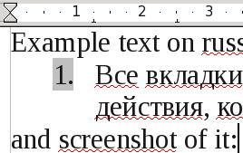
First problem: when cursor placed on gray square with 1. it becomes as arrow ↔ . Users my think, that they can move something left-right, but they can not.

Second problem: when we place cursor on gray square and click mouse and drag, then:
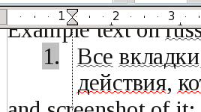 we can see dotted vertical line and paragraph sliders begin to move. Users can think, that they changing something. But nothing changes.

Thirst problem: when right click on gray square, users can think, that appears context menu, from which they can start dialog Bullets and Numbering. But nothing so happens.
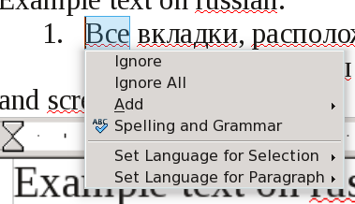

used LibreOffice 3.3.1.2 on Mandriva 64 bit Kde 4.4

