cornouws 2024-04-03

Test GTK3 widgets in LibreOffice Basic
Start example dialog with various widgets, different heights set.

Linux with GTK3, design (left) and result (right)

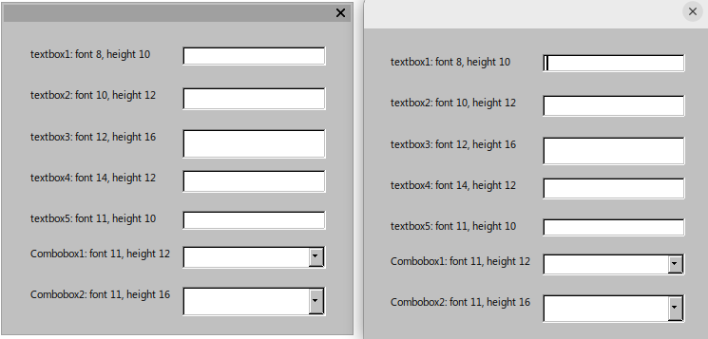
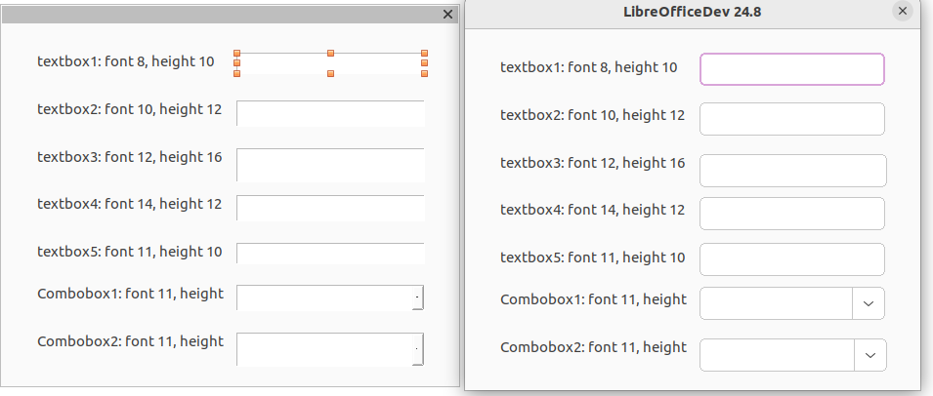
Linux with SAL_USE_VCLPLUGIN = gen, design (left) and result (right)

Version: 24.8.0.0.alpha0+ (X86_64) / LibreOffice Community
Build ID: 56767830b81fa21382b87cf43d78b1c73ca5dbd8
CPU threads: 8; OS: Linux 5.15; UI render: default; VCL: gtk3
Locale: en-US (en_US.UTF-8); UI: en-US
Calc: threaded

