Form contains 2 label fields and 2 text controls. Help text has been added in properties of first text control.
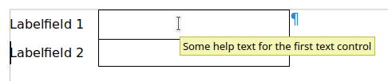Right help appears over first text control.

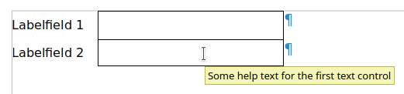Help of first text control appears also on second text control, if (slowly) moved from the first text control to the second text control.

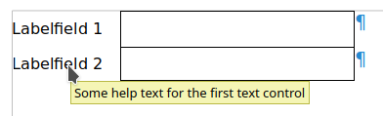Moved (slowly) vom second text control to the second label field and the help could also be read in label field.
The help will disappear if moving the cursor to the first label field. If starting with first text control and moving to first label field hepl text will appear also on first label field but will disappear when moving to second label field.
In forms this behavior could be very irritating. A field without any help text will show help from other controls. This could be help with different content (from different controls) and has nothing to do with the field.

