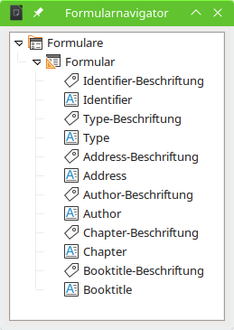
Set cursor in the control for "Identifier". Press tabluator to move through the form. Tab follows the order of fields in the form navigator.
Start Form → Form Navigator. Try to change the order by moving controls in the formnavigator by mouse. Won't work.
The only possibility is to set tabstop inside the properties of the form control (right mousclick on Control → Control Propertries → General → Tab order). But with tabstops in a formcontrol it will be impossible to jump, for example, to field "Chapter" by typing Alt + C.

