Version: 7.3.2.2 / LibreOffice Community
Build ID: 30(Build:2)
CPU threads: 12; OS: Linux 5.17; UI render: default; VCL: kf5 (cairo+xcb)
Locale: de-DE (de_DE.UTF-8); UI: en-US
Calc: threaded

LO freezes when sending Email

LO should be used to send a Mail to different recipients.
Starting with an empty profile:

docb@X1E:~> libreoffice --safe-mode
Qt: Session management error: networkIdsList argument is NULL
QTimeLine::start: already running
QTimeLine::start: already running
QTimeLine::start: already running
QTimeLine::start: already running
First the sender information is entered, and outgoing mail server tested:
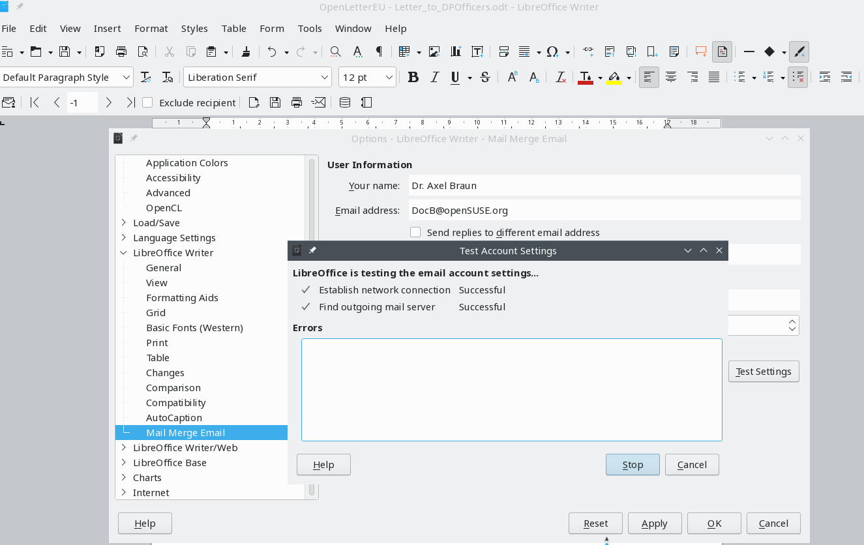

Next the mail is prepared as shown – note – only to the first recipient a mail should be sent (this was changed compared to the screenshot):

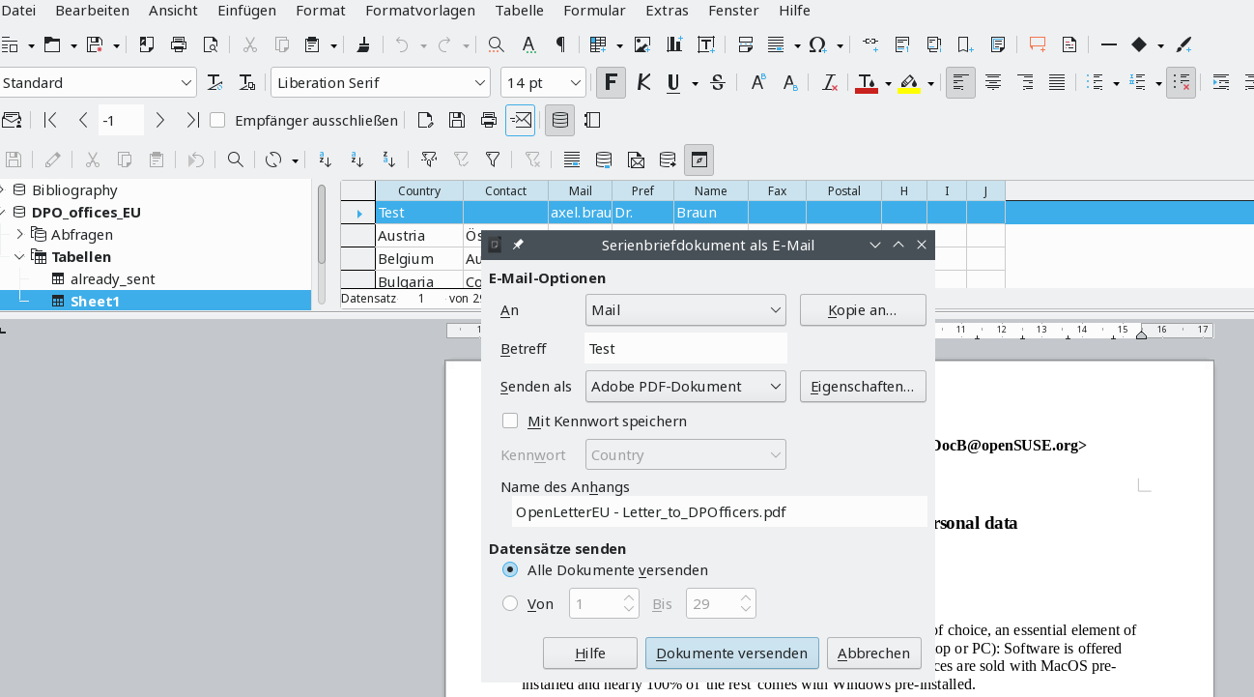

Now the sender information is requested again – why?

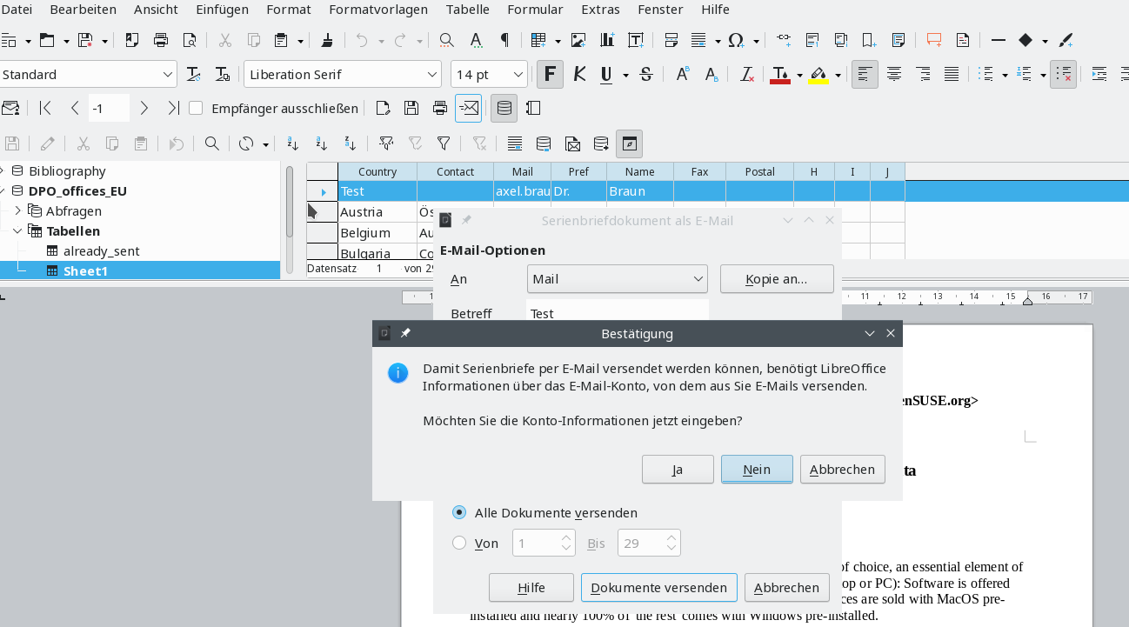

After entering the information and verifying that the smtp-server works I hit ‚send documents‘ and the application freezes completely. Process had to be killed. No further information in the terminal window.

