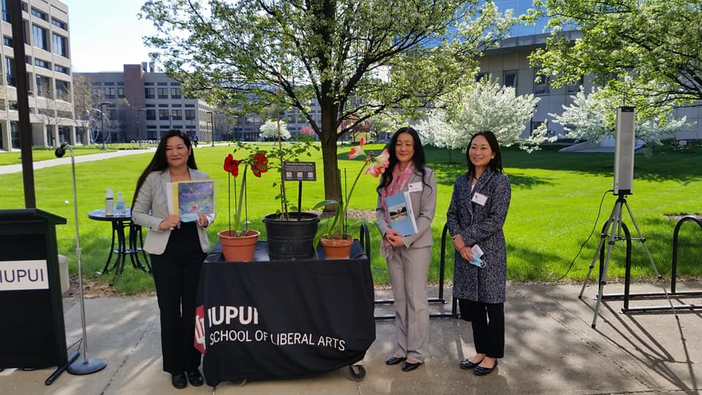
Further away, Indiana University-Purdue University Indianapolis held a planting and dedication ceremony on a sunny day in April, in conjunction with their annual Hiroshima Peace Event. Hideko and her daughter (and Michigan-based OSDI board member) Miko had been speakers the previous year, and were thrilled with the high level of student engagement. IUPUI compiled a wonderful booklet of photos, student peace declarations and writings of the two events.
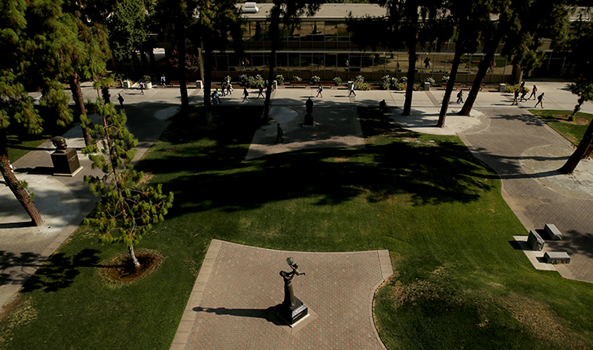
Closer to home, we have added to our website a few more photos and video of camphors sent to California through Miko's extensive contacts. We featured the August 6, 2020 dedication at California Health Sciences University College of Osteopathic Medicine in Clovis last year. Now we know 3 camphors were also dedicated at Fresno State University's student-initiated Peace Garden the same day, planted amongst sculptures of Mahatma Gandhi, Martin Luther King, Jr., Jane Adams, Cesar Chavez, Nelson Mandela, and Dolores Huerta.
~~~ Bug ~~~
The first line of the second paragraph will not wrap when the upper picture is between 1.54" and 1.61" in height. Original space below first paragraph is 0.08" and I got the bug to disappear if that value is changed and then changed back once but I am not sure how to replicate it. It still appears in this file even when changing the spacing. May be related to an old unused template that is still referenced since this document was created from another document that accidentally used that old template. Copying this content in to a new document using the default template does not show the bug.
(This is a section of a longer document).
Version: 7.2.1.2 / LibreOffice Community
Build ID: 87b77fad49947c1441b67c559c339af8f3517e22
CPU threads: 12; OS: Linux 5.4; UI render: default; VCL: gtk3
Locale: en-US (en_US.UTF-8); UI: en-US
Calc: threaded

