

Functions, Menus and Settings
Version 1.70

Version 1.70.60
© Dipl.- Ing. (FH) Thomas Neumann 2000-2020

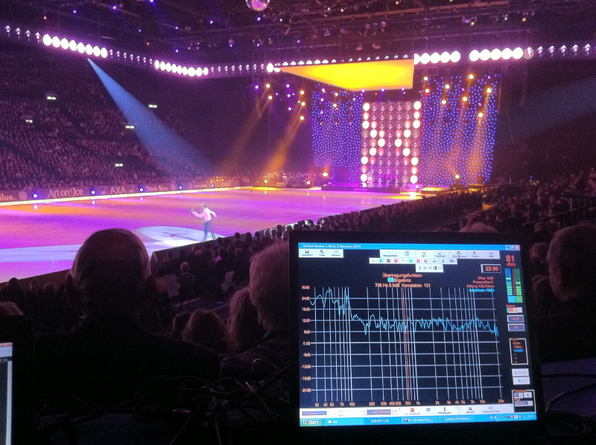

Thank you for choosing SATlive.

License / Registration / Terms of use
- If you like SATlive after some testing, you can order the full version which does not contain any limitations.
- Please use the demo to check the program's compatibility with your hardware and operating system.
- If you're facing troubles with the demo, the full version will not fix them. In this case please feel free to contact me, so we can try to solve your problem prior to registration.
- Please understand, that no liability can be taken for the proper function of the software with a specific hardware configuration. This case does not establish any claim to refund.
- According to today's level of engineering it is impossible to build a software which is properly working on all hardware / OS configurations.
- Please report all kind of problems to the forum or via e-mail (info@satlive.audio).
- The process of demo registration starts with the request of a demo key. The demo key has to be enabled after you received it via e-mail.
- To get and install a full version license, please follow the steps shown in the full key menu
- There are two kinds of registration:
- FULL: This license is linked to one computer and no physical device is used.
- DONGLE: An external hardware device, a so called dongle is used to enable the software. Therefore the license is not tied to a certain computer.
- The current price list can be found in the internet at https://www.satlive.audio/order, where you could place your order, too.
- After the purchase is completed, then in case of Full registration the buyer (license owner) gets the KEY-files via e-mail, which enable him to create a full-version basic-key. For the completion of the registration, he needs to send the full-version basic-key via e-mail to Registration@SATlive.audio. In return he receives a key-file which will unlock SATlive on the PC on which the full-version basic-key was created.
- For the dongle version, the buyer (license owner) gets a small hardware device, which could be plugged into any usb port. SATlive will operate as long as the dongle is attached to the computer.
- All following updates and versions (until recalled) are licensed to the license owner. Just look on the sat-page (https://www.satlive.audio) and when you see a higher version-number just download the newest version.

Demo version
The following limitations apply to the demo version:
- When starting the program there is a DEMO display for 10 seconds.
- The program stops after 10 minutes of operation.
- The program runs only for 30 days after first start.
- You can register for a 30 days full featured demo using the demo basis key.

Terms of license

Demo:
- You are allowed to handle the demo to other computer-users, so that they can also test the program. This is only allowed on the condition that all files are handled completely and in unchanged original state
- Remark for online-representatives, shareware-dealers and shareware-distributors: This demo can be put on CDs or be offered in online-services.
- You can find the most current version at
https://www.satlive.audio/en/portfolio/the-current-version/

Both, full version and demo:
- There is no liability on the declarations made in this help file and I reserve the right to change it without notice. There is no liability for the correctness of the declarations and descriptions in this file.
- Your report of problems or bugs helps to make the program and the help better.
- I don't take any guarantee for the suitability of this program and/or other programs for a special case of application or special hardware-configuration.
- I take no liability for any kinds of damages which result from the application of this program or the inability to use this software. This includes the loss of profit, the loss of data and all other material and immaterial damages and deduced damages. This applies also in the case that I've been informed of the possibility of that kind of damage.
- Any bug report can help to make SATlive better. So please report bugs using the error reporting window.
- It is not allowed to disassemble and/or to patch this program or parts of this program or any other file supplied with this demo or full version.

Full-version
- I grant you, the user and owner,. the license to copy the software on one computer and to use the program on that computer. It is allowed for other persons to use it on that computer too.
- Both licenses, full and demo are valid for one computer only. The user selects this computer by creating the basic-key on that machine. The keys will work only on the machine where their basic-key was created.
- The user declares his convenience with these terms of license without any limitations by installing and using this program.

LIMITATIONS on the FULLVERSION
- This software is only dedicated to the user and license-owner. It is not allowed to handle the license to other people, to sell or rent the software, the key-files or the dongle either temporary or lasting. To do so, a written permission is necessary.

FINALIZATION of the LICENSE
The license is valid until finalization. The license is finalized, even without notice, by any offense against these terms of license. After finalization you must destroy the original license and all kinds of copies of this program. On demand you have to confirm the destroying of the program and of the copies by a written statement.
All product- and company's names are trademarks of the corresponding manufacturer.

Request a Demo Key
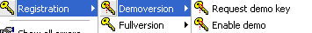
The first step to get the 30 day unlimited demo is to request a demo key.
Open the Request Demo Key window located at Help menu → Registration → Demoversion.

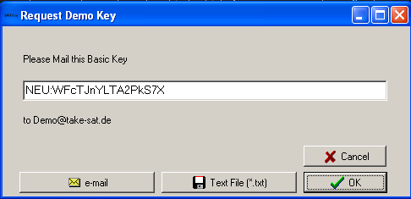
Now mail the demo basic-key shown in the window to the e-mail address demo@satlive.audio.
You can either create the e-mail by your own and add the demo basic-key using copy and paste, or simply click on the e-mail button to let SATlive create the mail.
If your PC is not connected to the internet, you can store the information into a text file using the Text File button. Use a portable device to carry the file to a PC with an internet connection.
In return you'll receive the demo key, which you need to activate.
Hints:
- The demo key you'll receive is valid only on the computer where the demo basic-key was created on.
- Please use the e-mail option to avoid typos, which would delay the delivery of the demo key.
- Please check the date and time settings of your computer before the creation of the demo basic-key.
- The demo-key handling is not automated, so please allow some time for response.

Enable the Demo-key
After the request of the demo key you'll receive the demo key via e-mail. Open the Enable Demo window located at
Help → Registration → Demo version
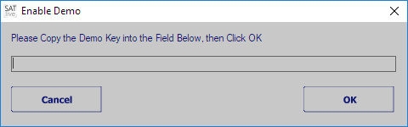
Just copy and paste the demo-key from the e-mail into the editor field on the enable demo window. Then click on OK and restart SATlive.
Hints:
- The demo-key you'll receive is valid only on the computer where the demo basic-key was created.
- Please check your date and time settings before creation of the demo basic-key.

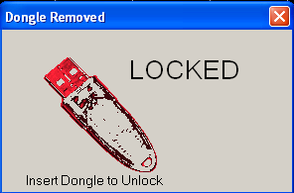
Dongle
An external hardware key device for the USB port, a so called dongle, is available for SATlive. The dongle enables SATlive on the computer on which it is plugged in.
SATlive locks if you remove the dongle.
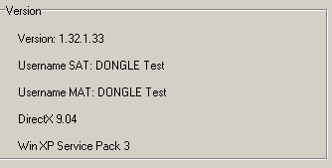
If the dongle is plugged in again, then SATlive unlocks and you can go on working.
If you close the window, SATlive terminates.
You can check for a valid dongle in setup → internal configuration (see page Error: Reference source not found).
Hints:
- The dongle must be plugged in before SATlive is started.
- The current display settings are stored on the dongle.

Basics
All rights reserved by Dipl.- Ing. (FH) Thomas Neumann (1998-2019).

- The author does not take any liability for damage caused by the usage of this software.
- This program is able to create sounds, which can destroy technical equipment and cause damage to human hearing.
- We suggest that you start with very low level and then adjust them to the level needed.
- For proper usage of this program you need basic knowledge of working with a computer and of acoustic measurement.

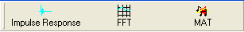
The three main modules of SATlive
- Impulse response: Here you can measure the system's impulse response using a maximum length sequence (MLS), or calculate it by comparing two signals.(Music Impulse Response (MIR)). An oscilloscope and a sweep based measurement can be found here as well.
- FFT: Shows phase and amplitude response of the impulse response measured in impulse response module. Furthermore you can compare and analyze traces
- MAT: Performs a dual channel FFT, shows the 'classic' RTA display or a FFT of one or both input channels.

The support and setup areas in SATlive
- Setup Allows you to customize SATlive to meet your needs. See page Error: Reference source not found for details.
- Clock Shows the current time or counts down to a given time. More details can be found on page Error: Reference source not found of this document.
- The Project management, described on page Error: Reference source not found, eases the handling of larger speaker configurations.
- Help access to the help file and the registration menu.

How to invoke a module?
To invoke a module, simply click on the particular button in the upper menu bar.
If you want to create a FFT of a measured impulse response, just invoke the FFT from within the impulse-response module.

What are the different areas in SATlive?
Because you can move the menus, the positions mentioned below refer to the default positions.
- Upper menu-bar located directly below the module – selection menu. Here you find the main measurement functions.
- Infodisplay located at the top of the trace display window. Shows information about the values at the cursor's position.
- Tracewindow the main window, showing the current trace(s). In most cases its popup menu contains tools and functions for analyzing the current trace.
- Lower menu-bar located below the trace window, it contains functions and settings for the layout of trace window. In MAT module it also contains functions for delay setting.
- VU-meter located right of the trace window. It shows the current input levels.
- Right menu-bar this menu is located below the VU-meter and features more functions.
- Generator located on the lower right edge. It supplies different kinds of audio-signals.

Language files
– This information is not valid for the Spanish language version of SATlive –
All the text information used in SATlive is stored in an external file, the so called language file.
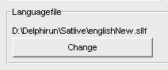
You can select the language file you want to use in the Setup → Features window by clicking on the change button in the lower area.
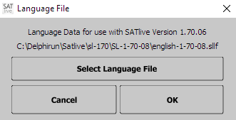
This opens the language file selection window.
To select the language file you want to use, click on Select Language File.
The top most line shows the name of the currently selected language file. If no valid file is selected, then this line shows ---.
The bottom line shows the folder in which the currently selected language file is located.

Hints:
- On the start of SATlive the software scans for language files in the current directory. If it finds more than one language file, it uses the youngest file of the selected language.
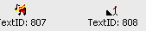
- If you're using an older language file, which may lack some strings needed, SATlive will display Text ID: followed by the missing index instead, and it will show the language-file selection window on each start.
- On the first start of a new version the language selection window is shown during start-up.

About this document
- Button's names and menu entries are shown in italic letters: Button Save means that you need to click with the left mouse button on the button labeled 'Save'. Please be aware that in some modes, the buttons will show only the icon, not the label.
- When you need to select an item from a menu or a list, the different steps are separated by an arrow. Setup → Options means: Do a left click on the button Setup then select Options from the popup menu.
- Nearly all buttons and displays in SATlive contain a popup menu. On the buttons this is indicated by a small arrow at the button's right side. To open a popup menu, you can either perform a click with the right mouse button on the button or a click with the left mouse button on the arrow.
Hint:
- SATlive features two kinds of menu layout which can be changed in the setup → display window. See page Error: Reference source not found for details.

Terms
- Live Trace and Current Trace are used to label the result of the current measurement. Depending on the module, the measurement can be still active or finished.
- The Selected Trace is used to indicate the trace currently selected for processing. By default the selected trace equals the current trace.
- The current measurement is the measurement which created the current trace.
- Popup menu: A popup menu, also known as context menu, contains specific functions for related area. You can open it with a click with the right mouse button on the related area (button, display and so on).
In a menu bar a popup menu is indicated by a small arrow at the button's right side. You can click on the arrow with the left mouse button to open the popup menu.
- In SATlive the term Peak is used for the point with the highest absolute value.
  - In the impulse – response module, the peak is helpful for the time alignment. You can use it as the reference for the window's position or the group delay.
  - In the MAT and FFT module the Peak is the point with the highest amplitude value.
  - Use the shortcut P to place the cursor at the current trace's Peak.
- The FFT Resolution indicates the distance between two points calculated by the FFT algorithm. The FFT Resolution is displayed in the selection of the FFT size.
A better resolution means a larger FFT size.

Memory trace
In the impulse–response module, in the FFT module and in the MAT module you can copy the live trace into a memory using the shortcut F5.
This copy, called the memory trace, gets exactly the same settings (Gain, smoothing) as applied to the live trace. The shortcut F6 toggles the memory trace's visibility.
Hints:
- The memory trace is lost when you exit the program or assign a new memory trace.
- In the impulse – response module the current impulse response is assigned to the second impulse response trace, which means that in this case F5 is similar to a click on the Assign button in the top menu bar.
- To read out the values of the memory trace you select it as the selected trace (see page Error: Reference source not found for details).
- You can use the function Load memory trace from file in the Tools menu to assign a stored trace to the memory trace.

Move the cursor using keys
The following keys can be used to move cursor in SATlive:
- Cursor right, Cursor left move the cursor one step in desired direction.
- Cursor right/left and Shift move the cursor by ten steps.
- Cursor right/left and Ctrl move the cursor by one hundred steps.
- Home Set the cursor on display's right border.
- End Set the cursor on display's left border.

Averaging
Averaging is available for all measurements in SATlive.
If you use averaging then the same measurement is performed more than one time and a mean value of all results is calculated and displayed. This reduces the influence of ambient noise to the measurement's result.
- In the impulse – response module the trace is shown after all measurements are done.
  - The amount of measurements to be averaged is selected in the measurement's setup.
  - In setup advanced sampling you can select the way SATlive handles differences in the single measurements.
- In the MAT module all measurements are performed consecutively and a so called FiFo averaging is used, except for the Average All setting.
In a FiFo (First In, First Out) averaging the results of the older measurements remain in memory. When the memory is filled up, then the oldest measurement is replaced by the current measurement's result.
After each measurement, the mean value of all data in memory is calculated.
There are two options for the calculation of the mean value in the MAT module.
- First one is the complex averaging, which is performed prior to the calculation of amplitude and phase values.
- Second one is the RMS averaging, which averaging calculates the amplitude value of each single measurement and averages the amplitude values. This excludes the phase from the display and makes the amplitude display more stable, especial for larger distances between the speaker and the mic.
- There is no FiFo averaging used MAT module if you select Average all Values.
The amount of averages and the averaging mode can be set in the layout area, which is located in the bottom menu area. For more details related to averaging, especial in the MAT – Module see page Error: Reference source not found.

Trace's description
In SATlive you can assign and edit a description to every trace.
If you’ve selected remarks in Setup → Features → Fileinfo then the trace's description is shown when the trace is used as calibration, overlay or mic – correction data.
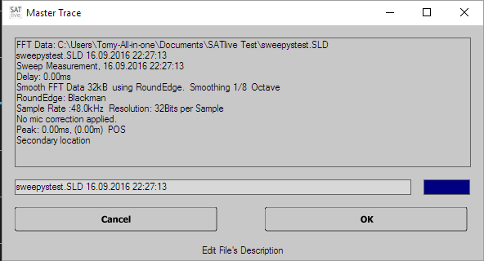
You can edit the trace's description in the information window. You can toggle the trace's weighting using the button right of the editor field.
You can open the info window by:
- A left mouse button click on the symbol
- Using the keys shift + I on your keyboard.
- If the option Show Fileinfo when saving is selected in Setup → Features, then the info window shows up every time you save a trace.

Connections
In order to do correct measurements, you must wire SATlive correctly.
WARNING:
- Wrong connections can destroy the pc's soundcard or
even other parts of the pc.
- NEVER connect an output or input to a speaker output or mains.
- Lower all external volume controls to minimum before starting SATlive.
The Output signal (soundcard's Line out) should be connected to an input of the console or of the device under test.

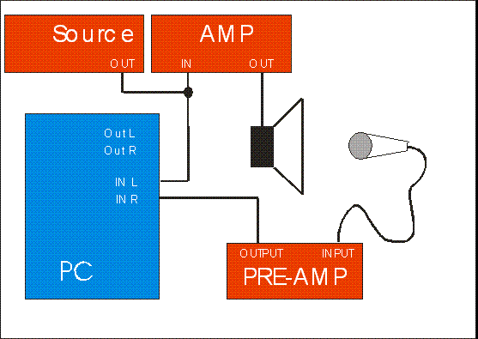
Using an external signal source
- The Reference input (By default Left In) receives the signal from the external source.
- The measurement mic is feed into the Mic input (By default Right In).
- Make sure that you feed exactly the same signal into the computer and into your sound system.

Using a measurement signal created by your computer
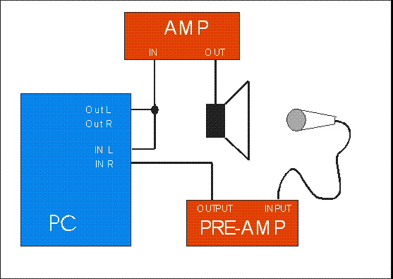
- Feed the output-signal from the computer's Audio-output into your soundsystem and in the Reference input (By default: Left Input).
- Feed the signal of your measurement mic into the MIC input (By default: Right Input).
- You can either use an external mic – preamp or an audio-interface with a build-in preamp.
- Your measurement mic will need phantom-power.
- If there is only one input on your computer, you can use the direct-reference feature, which is explained on page Error: Reference source not found.

Measurement of an electronic device using the PC as signal source
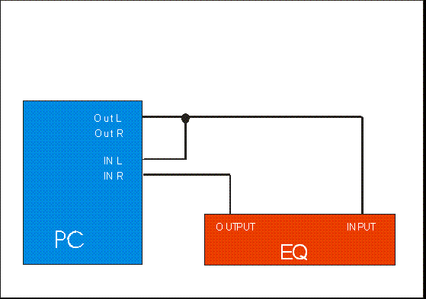
- Feed the signal from the PC's audio-output into the device under test and into the Reference input (By default: Left Input)
- Feed the output-signal of the device under test into the MIC input (By default: Right Input).
- Never connect any speaker output to an audio-interface.

Setup and verification:
- Use the VU meter to adjust the levels. Select Pink Noise at the signal generator and start signal using the speaker symbol or the shortcut G. Adjust the level using the level adjustment in the signal-generator section or the shortcuts arrow up / arrow down, the windows mixers and your hardware.
- Go to the windows mixer, select the line input for recording, and adjust level so that VU meter's left (reference) bar shows approx. -10dB.
- Now set the gain of your mic-amp so that VU meter's right bar shows approx -10dB
To verify your settings, please perform the following checks:
- Stop the signal generator and talk into the mic.
  - If you can hear your voice in the speaker, or you're faced with a feedback at the level – set procedure, there is a link between input and output.
You need to disable this 'feature', often called Direct (or zero latency) Monitoring. To do so, please refer to your manual of your audio device.
- Switch off the amp, and restart the signal-generator, using the (you remember?) the button or the shortcut G.
- Now remove direct link between the output and reference input.
- If the VU meter's left side still shows a signal, you need to change your soundcard's recording mixer (set recording level for line out and mixerout to zero).
  - If only the VU meter's left side shows signal, you've just flipped the inputs.

Measurement
Important: To archive a correct result, the system must not change during the measurement. Therefore any dynamic processing like exciter, compressors and so on have to be bypassed.
Furthermore make sure that in the sound-card's mixer all 3D or the reverb effects or any other 'improvements' are disabled.

How to start a measurement?
In SATlive there are three different ways to start a measurement:

- Starting a measurement with a mouse-click (Impulse response module). You have to select the kind of measurement first, then you may adjust some parameters of measurement and finally start it by clicking on the button showing the selected measurement. In the complex menu layout this button is located above the trace-display window, in the simple menu layout it is in the lower menu bar. When the measurement is finished, you got a raw impulse response trace.
- Running a macro (Impulse response module). In this case you do not only start a predefined measurement with predefined settings, but also activate a defined treatment of the measurement's result. You can access two macros direct using Room/Speaker and Direct/Equalizer . To reach the other macros just click on User Macros M. This will open a list containing all twelve macros available. You can edit the macro settings at Setup → User Macros.
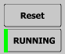
- Automatic start of measurement (MAT module). In this case the measurement starts when you enter the module.
In the MAT module use the button Running/Frozen or the spacebar to control the operation. A green vertical line at the left of the button indicates a running measurement and a red line indicates a stopped one.
- When you change the measurement mode, the old measurement stops and afterwards the new measurement starts. Use the button Reset or the shortcut R to reset averaging and the Running/Frozen button on the right or the space-bar to start/stop the measurement.

How to prepare for the measurement?
- Connect your audio-interface and your hardware (See page 16).
- Check your wring and hardware settings by playing back pink noise (see page Error: Reference source not found) and watching the VU meter during this test.
- For the impulse-response module you should create either a calibration file (see page Error: Reference source not found) or the complex – calibration feature (see page 57)
- If you like to perform an absolute level measurement, you must adjust the level reference before the measurement (see page Error: Reference source not found).

How to deal with problems?
- Problems related to wiring will bring up an error message (level too high, level too low) in the impulse-response module.
- Check the wiring and the settings of the soundcard's mixer, as described in the connection topic on page 16.
- Try using different latency settings.
- Try another soundcard or use a different audio driver. (Setup → I/O Devices). See page Error: Reference source not found for details.
- If you cannot solve your problems, please send an e-mail with a close description of the problem to Info@SATlive.audio.

Part one: Reference

The Impulse – Response Module
The impulse–response module features different methods to measure the impulse-response. Furthermore it contains an oscilloscope simulation, so you can look on the input signals directly.
To invoke impulse response module click on the Impulse response entry in top menu bar. The result of the measurements is an impulse response.

More about the Impulse Response
The impulse response is the output of a system feed with a very narrow and very high single impulse.
This is an ideal impulse response. There is now delay and you just see the initial impulse.
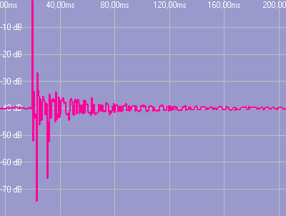
This is a real world impulse response. Here you can see the initial delay and some discrete reflections.
The main purpose of the impulse response is the analysis of time related parameters, like delays and room acoustics.
You can transform an impulse response into a frequency response using a FFT calculation.
There are different ways to display an impulse response graph (see page 32 for details)

Select Measurement and start it (complex menu layout).
You find this area in the top menu bar.
Loop Measurement repeat the current measurement until you stop it, and display the result after each measurement's completion. You can combine this option with averaging.
- Select the measurement you want to perform from the selection, or select it using the shortcut F3.
  - MLS White MLS measurement using pure MLS sequence.
  - MLS Pink MLS measurement using pink filtered MLS sequence.
  - MIR Measurement dual Channel Algorithm to measure impulse response.
  - Sweep Measurement dual Channel Algorithm using a special excitation signal.
  - Oscilloscope show an oscilloscope to look on both input signals.
- GO the currently selected measurement's symbol is shown right to the selection box. Click on the symbol to start a measurement. The function's shortcut is F4.
- Setup show the current measurement's setup. The function's shortcut is F9. The symbol changes with the measurement selected. There is no setup for the oscilloscope measurement here, because all settings for the oscilloscope are located in the right menu area.
- You can access the setting for the currently selected measurement in the Setup menu at the top menu bar also.

Using in the IR – Module
The Ir – module uses a more scientific approach to measurement than the MAT module (see page Error: Reference source not found). The whole process consists of a defined sequence of different steps.
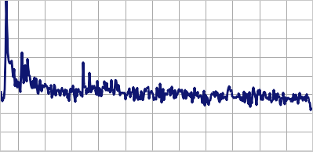
- Measure the impulse – response. There are different methods available to get the impulse – response of the system of interest. See page 58 for details of the different measurements and their options.
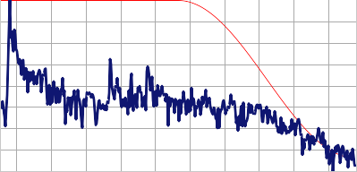
- Once you’ve measured the impulse – response you can show it in different ways (see page 32) and analyze it.:
  - You can simply read out time values by placing the cursor on the point of interest. If you’ve latch the cursor using the D key, SATlive will show the difference between both positions. See page 25 for more details about the options related to the cursor.
  - If wanted, you can use the impulse – response for room-acoustic calculations (see page 40).
  - Use the cursor (see page 25) to select a certain part of the impulse response for further analysis. This selection is called windowing (see page 27).
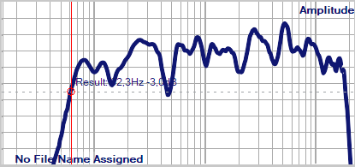
- You can transfer the selected part of the impulse – response into the frequency domain, where you’d be able to look on the frequency – response. To do so, use the FFT and Smooth – FFT functions. See page 72 for further details.

Using the cursor in the Impulse-Response Measurement
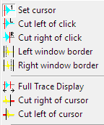
Choose the current operation mode of the cursor from the popup menu of the main display area.

Move the left window border
- The option Left window border can be found in the popup menu of the trace display in the impulse – response module.
- If this option is activated, then the left border of the upper trace window can be moved using the cursor keys.
- The actual value of the border will show above the trace window.
- The upper window always shows the data used for the FFT. The lower window shows the whole impulse response with the selected part marked in a different color. You can use the Left window border function on both windows.
Hint:
- If the width of the window would exceed the maximum FFT size (64k Samples), the right border will be adjusted to keep the size at 64kSamples.

Move the right window border
- In the impulse-response module you find the option Right Window Border in the popup menu of the trace display. In complex menu-mode it is also located in the right menu area.
- If this option is activated, then the right border of the upper window can be moved using the cursor keys.
- The actual position of the right border is shown above the trace display.
- The upper window always shows the data used for the FFT. The lower window shows the whole impulse response with the selected part marked in a different color. You can use the Right window border function on both windows.
Hint:
- If the width of the window would exceed the maximum FFT size (64k Samples), the left border will be adjusted to keep the size at 64kSamples.

Cut right of cursor
In the impulse-response module you find this function in the trace's popup menu.
The right border of the upper window is set to the cursor's current position. This action is enabled only if the option Set Cursor is selected.

Cut left of cursor
In the impulse-response module you find this function in the trace's popup menu.
The left border of the upper window is set to the cursor's current position. This action is enabled only if the option Set Cursor is selected.

Full Trace Display
The function Full Trace Display is located in the impulse - response module's trace window's popup menu. It sets the upper window to the maximum FFT size (or to the size of the impulse response, if it is shorter than maximum FFT size).
Hints:
- The program tries to keep the current left border of the upper window. If the right border would exceed the actual size, then the left border is readjusted.
- This option can also be accessed using the shortcuts F or CTRL – F.

Save the Current Window
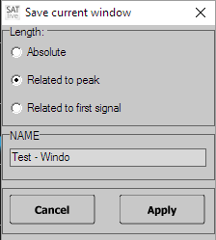
In the impulse-response module this function saves the current border positions of the upper trace display as a user defined window. This function is located in the trace's popup menu.
- Click on Save Current Window.
- Select the target to save the current window to.
- Select the reference for the window's position. Edit the window's name.
- You can verify and edit the window's parameter in the User Windowing section. See page 28 for details.

Windowing
For the analysis of the signal we use only a part of the signal. Just cutting might create some problems at the borders of our signal. So we can choose a so called windowing function to fade out. When you use an impulse – response we assume that there are no problems at the start of the interval because in most cases no significant amount of energy exists before the impulse response. In the dual – FFT measurements the windowing function will be used for both, fade – in and fade – out of the signal.
Use the windowing – window to control the windowing.
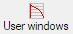
You can access that window either by the entry User Windows in the popup menu of the trace – display area or by clicking on the User Windows symbol in the menu – area right of the display.
The current windowing function is applied to the signal prior to the calculation of the FFT or smooth – FFT.

Display the windowing function
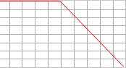
The sub – menu Layout in the popup menu of the trace – display area contains the entry Display Window Function. Use this entry to control the display of the windowing – function in the upper display – area.

Visualization of the windowed impulse – response
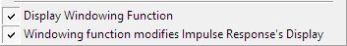
Use the entry Windowing Modifies Impulse Response’s Display in the sub – menu Layout in the popup menu of the trace – display ares to choose whether the selected windowing – function should affect the display of the impulse – response.

The window User Windows
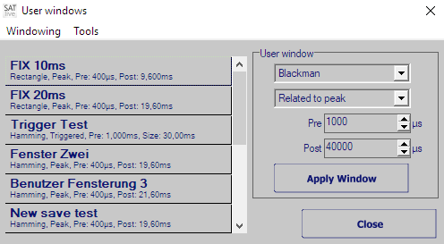
This window contains the settings of the windowing function (see page 27) used in the IR – module.
You can invoke it using either the button User Windows in the right menu – area or the entry User Windows in the popup menu assigned to the display area.
On the left you’ll see the twelve presets available. Just click on an item in the list to recall it’s settings. The changes will show immediately in the display.
Use the area on the right to configure the window. To apply this setting click on the Apply Window button.
Note: If you’ve enabled the entry Close After Recall in the menu Tools, the window will close after a window has been applied, either via the Apply Window button or by clicking on a preset, the window will close automatically.

Parameter to edit
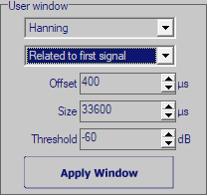
In the right area of the user – windows editor you can configure the window to fit your demands.
Use the selection at the top of this area to choose the windowing function.
The second entry defines the reference in time used for the window:
- Absolute the window will start on a fixed time position (Left), and will have given size (Size).
- Related to Peak the impulse response's peak is used as the time for the window to apply. This is a good choice for measurements with varying time delays. You can edit the window's left distance to the position of the peak (Pre) and the window's right distance from the position of the peak (Post). The total size of window will be the sum of Pre and Post. Choosing a negative value for Pre will leave the peak of the impulse – response outside the window.
- Related to first signal takes the position where the impulse response first meets the threshold level will server as reference for the window. The position of the window will be defined by the offset setting, while size determines the length of the window.
Use the menu Tools (see page 30) to copy your settings to or from a preset.
Use the button Apply Window to apply your settings to the impulse – response.
Hints:
- You can perform manual windowing using the cursor and the trace display's popup menu as well. See page 25 for details.
- The peak of the impulse – response contains most of energy and information. Except for some special tasks, like looking on the reverb only, the window should include the peak.
- SATlive supplies two default windows. You can access the two windows with 10ms and 20ms size, related to the peak, either using the shortcuts Ctrl + 1 and Ctrl + 2 or click on the button or the button.

The menu of the user – windows editor
You can find this menu in the editor window of the user – windows (see page 28).
- Windowing: this menu contains the entry Close. Close will hide the window and return to the impulse – response measurement.
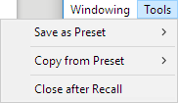
- Tools:
  - Save as Preset: Use this entry to copy the current settings of the right area (see page 29) into one of the ten presets. Choose the target preset from the sub – menu. You can not assign to the fixed window presets FIX 10 and FIX 20.
  - Copy from Preset: Copies the values of the preset selected into the edit area (see page 29) on the right. Choose the source preset from the sub – menu.
  - Close after Recall: If you’ve activated this entry, then the window will close automatically each time you apply a window, either using the Apply Window button in the right area or recalling a preset from the list on the left.

Second impulse response trace
In the impulse-response module SATlive supports two impulse response traces, which can be displayed at the same time.
There are two ways to assign a trace to the second trace:
- Copy the current trace to the second trace using either the F5 key or click on the Assign button in the top menu bar.
- Load the second trace from a file using the Load second IR function from the menu Tools.
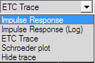
If a second trace is assigned then a trace display mode selection is shown above right above the trace display. See page 32 for details.
In that selection you can select the kind of display used for the second trace.

How to save the impulse response?
Use the Save function to write the current impulse response to a file. If enabled in Setup → Features, the info window is shown prior to saving where you can edit the trace's description prior to saving.
If you want to save the impulse response for the use with other software or for the use as complex compensation data, then you have to select the type of file from the save button's popup menu.
See page 57 for details about complex compensation.

Trace display modes in the impulse – response module
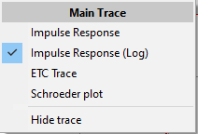
There are different ways to display the impulse – response.
You can select the kind of display you want to use using a selection box located above the trace display window.
The left selection affects the current impulse – response, the right selection the latched (second) impulse – response.
The x – axis shows the time, and the y – axis shows the amplitude value in different ways.

Impulse response
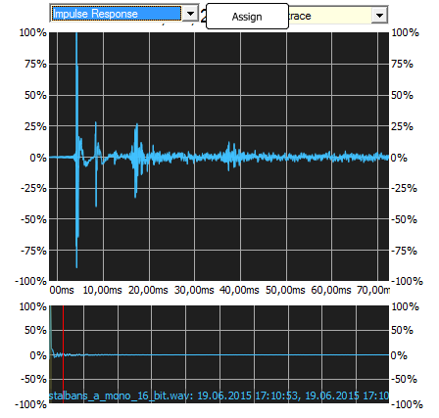
This display shows the impulse – response over time using a linear values and a linear scaling. This is the most basic display.
The lower display always shows the full size of the impulse – response in the linear display mode.
You can use the layout setting (see page 36)to change the display of the trace.

Impulse – Response (log)
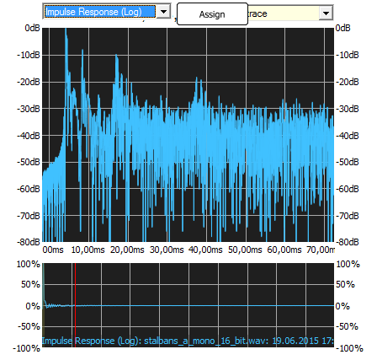
This kind of display shows the amplitude – values on a logarithmic scale. The logarithmic scale, a scaling close to the human reception of levels, makes it easier to detect peaks in the low level part of the impulse – response, which would be nearly invisible on a linear scale. The highest amplitude value is taken as the zero dB reference.
You can vary the display using the Display all data setting (see page 36).

ETC – (Energy Time Curve)
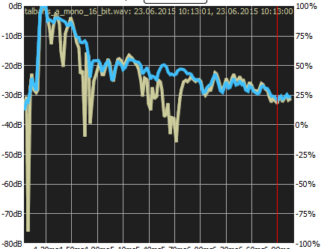
This display shows the energy content of the impulse – response. This display creates an envelope of the impulse – response, making it easier to detect global effects. The amplitude is shown using a logarithmic scale, with the highest amplitude value as reference.
You can vary the display using the Display all data setting (see page 36).

Schroeder Plot
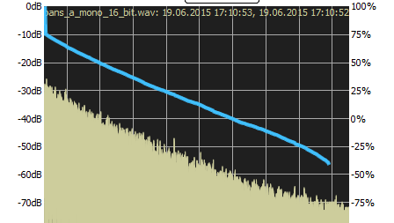
The Schroeder Plot shows the backward integration of the squared impulse – response. The backward integration creates a very smooth trace, which is used as the basis for a lot of room – acoustic calculation.
A common problem with the calculation of the Schroeder Plot is noise, which will affect the result.
There are different approaches how to deal with this problem.
Use the Configure Schroeder Trace window, described on page 34 to adjust the calculation of the trace according to your needs.

Configure Schroeder Trace
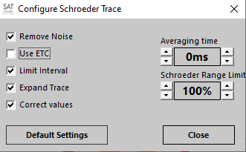
As mentioned above (see page 33), there are some parameters which will affect the Schroeder – trace. Especial the noise floor might create problems.
There are different approaches to deal with this challenges.
SATlive offers you the possibility to affect the calculation by choosing the calculation method and the amount of averaging applied prior to the calculation of the Schroeder trace.
You can change the settings in a small window, the so called Configure Schroeder Trace window.

Invoke the Configure Schroeder Trace window
In the IR – module use the menu – entry Configure Schroeder Trace in the menu Tools.
In the Room – Acoustic window (see page 40) you can either use the Configure Schroeder Trace entry in the menu Room – Acoustic, or the entry with the same name in the popup menu of the upper display area. A mouse click onto the status area at the bottom of the window also shows the window.
The options at left of the window enable you to choose the desired algorithm used for the calculation of the Schroeder trace. See the page 35 for details.
The setting Averaging time on the lower left controls the amount of averaging applied to the data prior to the calculation. A longer averaging time will improve the detection of the RT60 values but it might affect the calculation of the EDT, especial when the impulse – response shows a fast decay at its beginning.
Please note that any change in this window will trigger a new calculation, which might take some time, especial in the Room – Acoustic window, where a lot of traces will be calculated.
The button Default Settings at the lower left will reset the settings to their suggested values.

Algorithm used for Calculation
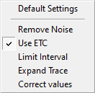
The Configure Schroeder Trace window (see page 34) allows you to change the algorithm used for the optimization of the Schroeder trace.
- Remove noise: The mean value of the last 10% of the full impulse – response are used to calculate the mean value of the noise – floor. Afterwards this value is subtracted from the impulse response to reduce the effect of the noise.
- Use ETC: Calculate the values based on the ETC (see page 33). Otherwise the calculation will use log logarithmic impulse response.
- Limit Interval: Estimate the noise – only part at the end the measurement and excludes it from the calculation.
- Expand Trace: Extends the trace below the noise – floor using the later part of the calculated trace.
- Correct Values: Estimates the amount of valid data removed by the noise – removal and adds it during the calculation.

The image below shows some traces based on the same impulse response but calculated different settings. See the upper right area of the image for details of each trace.

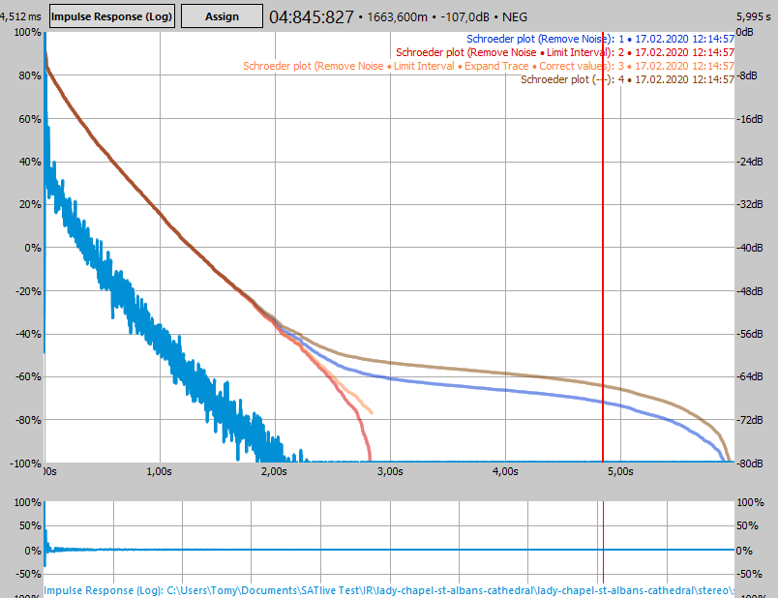

Layout of the trace display (Display all data)
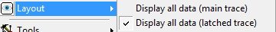
Depending on the current settings, the impulse – response trace might contain a lot of data. Therefore there are two ways to display the trace.
You can select the mode from the sub – menu Layout in the popup menu of the trace – display.
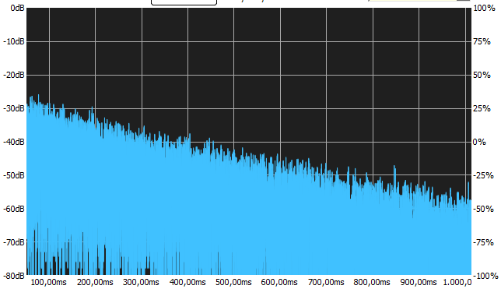
If the entry Display all data is checked, then all values will be drawn. For the full display of a large impulse – responses this might take some time due to the large amount of values.
To reduce the time needed for painting the width of the trace – display is limited to one pixel.
You can enable this option for the main trace using the entry Display all data (main trace). The entry Display all data (latched trace) in the sub – menu affects the display of the second (latched) trace.
The entry Show all data in the popup menu of a Quick – trace (see page Error: Reference source not found) allows the control of its display.
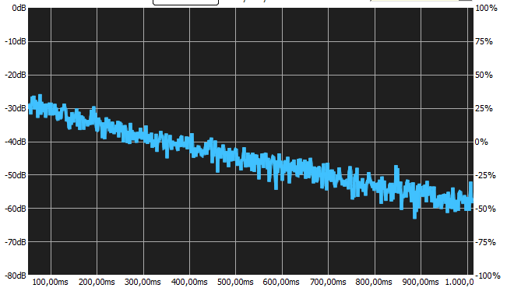
If this option is deactivated, then only one point is drawn for each pixel of the x axis. The value drawn is the value with the highest amplitude value within the time interval assigned to this pixel. If a wide range is displayed, then this display is similar to an envelope of the trace.
The display might change when you change the range displayed or if you change the size of the display.

The Delay-Matrix
The delay matrix shows up to thirteen time values and the difference in time between each of them. You can also add a fixed delay to the values, in order compensate for a change in the reference delay after the measurement of the delay values.

Values used
The delay matrix always contains the current position of the ten time-markers (see page Error: Reference source not found for further details).
In the measurement of the impulse – response in the MAT module the position of the cursor, and the peak – positions in the upper and in the lower (zoom) area will show in the matrix also.

How to invoke
The entry delay matrix locates in the menu Marker in the pop – up menu of the trace area.
Furthermore you can find it in the marker menu in the top menu area of the delay – finder (see page Error: Reference source not found). In the MAT module you’ll find this entry in the pop – up menu of the delay section (see page Error: Reference source not found) also.
You can use the web – interface (see page Error: Reference source not found) to access the delay – matrix.

The Display

The upper Area
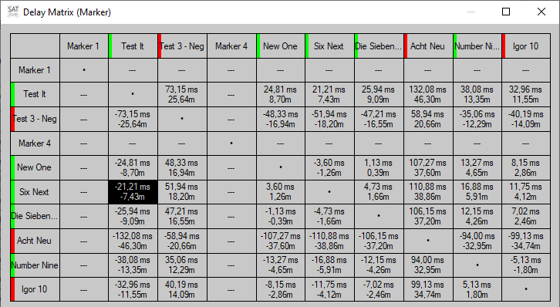
The upper area of the window contains a matrix that shows the difference in time and the distance calculated from the difference in time, related to the values assigned to the column and row.
The values show the delay to add to the position assigned to the row selected to reach the value assigned to the selected column.
You can select a cell by a mouse click. The values related to the selection will show in the lower area.
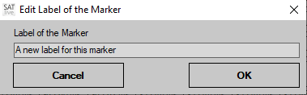
- To modify the label of a time – marker just right – click on its current label. This will open up a small window where you can edit the label.
- The color bar at the left indicates the polarity at the position of the marker at the moment of its assignment. A green bar indicates a value above zero and a red bar a value below zero.

The lower area
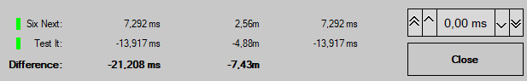
If a cell is selected, than the lower area shows more details about the entries assigned to the row and column.
If you select a cell in the left most column or in the topmost row, the lower area shows the information assigned to this entry. If you select an other cell, the information of both, column and row is shown in the lower area. The two upper lines contain:
- The polarity information at the moment of assignment. A green bar indicates a positive and a red bar a negative value.
- The label of the entry.
- The time value assigned to the entry
- The distance, calculated using the time value.
- The modified delay value, which is the sum of the time value and the offset value set by the time editor on the right.
The bottom line shows the difference, both in time and distance.
As long as the cursor is over the upper area the status – bar at the bottom of the window will show the row and the column of the cell at the current position of the cursor, which might differ from the cell selected.

Room Acoustic Analysis

Speech Transmission Index (STI)
The Speech Transmission Index (STI) is a value used to determine the intelligibility at the position of the measurement microphone.
The value considers the loss of modulation during the transmission of the sound, but not its frequency response. SATlive uses the impulse response to calculate the STI value.
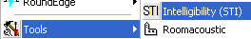
You can invoke the STI window from the Tools menu. If you’re using the menu mode complex then there will be a button STI in the upper menu bar. The loss of modulation is calculated for different frequencies used for modulation, and for different octave bands of the audio signal. There are 98 values which will be averaged using different weighting factors, based on the voice type setting, to get a single number as result.

The Window
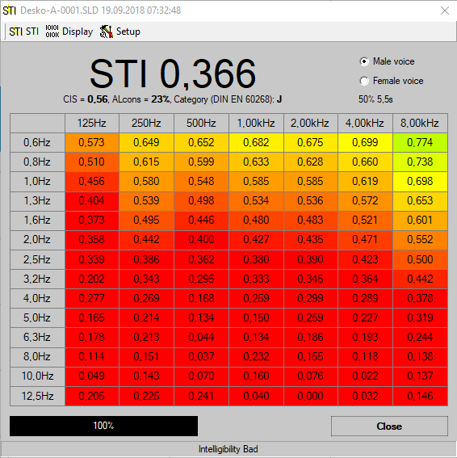
The top area shows the STI value calculated. Below the STI value you’ll find the values for CSI and AL_{cons}, both calculated based on the STI value. Right to this values the classification of the STI value according to IEC 60268.
At the upper right you can select the type of voice used for the calculation. The setting Male voice is the commonly used.
Below of this selection the part of the impulse response used for the calculation is shown. This part always starts at the start of the impulse response. Please note that for the good result this part needs to be longer as the RT₆₀ of the room examined. You can change this setting in the STI entry of the menu. See page 41 for further information.
The center of the window shows all 98 values. Use the entry Display of the menu (see page 41) to change the type of this display.
Use the button Close at lower right to return to the impulse response module.

The menu bar of the STI window
The menu bar of the STI calculation offers some options for the post-process and the display of the calculated result.
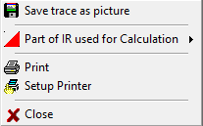
On the left there is the menu STI which contains this options:
- Save trace as picture use this function to save the current display of the STI values. Select the format of the picture in the save dialog.
- Part of IR used for Calculation this setting allows you to exclude some of the tail of the impulse response from the calculation of the STI value. For a good result the length of the remaining part should exceed the RT₆₀ of the room examined.
The current setting will show at the display’s upper right area.
- Print use this function to print the current display, information about the impulse response used as base for the calculation and a remark, which SATlive prompts for.
- Setup Printer use this function to change the printer and its properties.
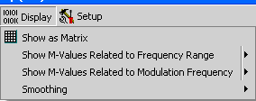
- Close closes the window and returns to the Impulse Response module.
The next entry is the submenu Display
You can select how to display the results of the STI calculation.
- Show as Matrix shows all values as numbers in a table. If the option Results colored in the menu Setup is selected then the background color of each value displays according to the value.
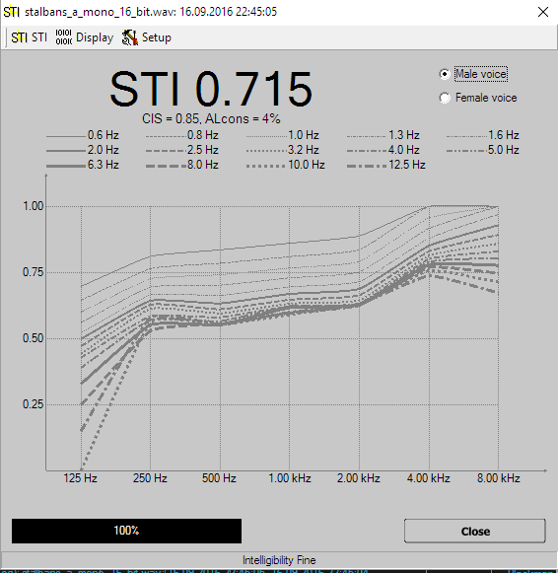
- Show M-Values related to Frequency Range draws the values as a function of the different audio bands used for calculation. For each frequency of modulation a single trace is drawn. You can enable the display of individual traces in the option's sub menu.
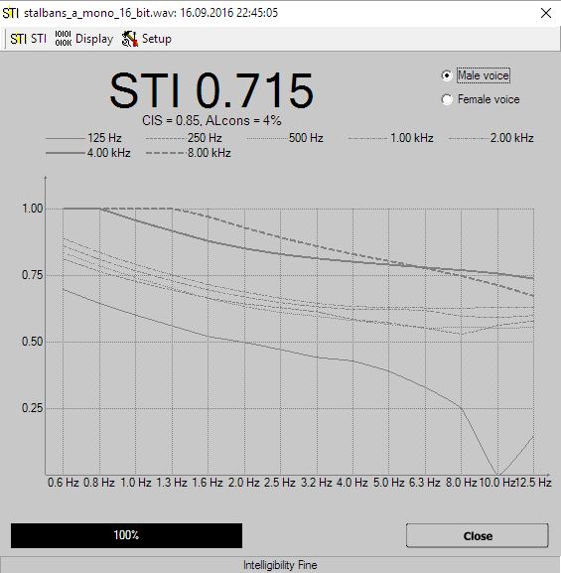
- Show M-Values related to Modulation Frequency draws the values as a function of the different frequencies used for modulation. For each band of the audio signal a single trace is drawn. You can enable the display of individual traces in the option's sub menu.
- Smoothing in the function's sub-menu you can select how much smoothing is applied to the traces.
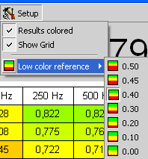
The rightmost entry is the menu Setup.
- Results colored assign a background color to each value according to its value. This setting affects only the Show as Matrix display.
- Show grid shows a grid separating the individual values in the Show as Matrix display.
- Low Color Reference sets the threshold for the red color. Any values below this value is shown in full red in the Show as Matrix display. A value of 1.0 is shown in full green. This setting affects the layout only if the Results colored option is activated.
Hint:
- Below the display of the STI value in the top bar you can find two other values used for the judgment of intelligibility. Both are calculated based on the STI value.
  - AL_{cons}, an abbreviation for Articulation Loss of Consonants, a number that aims on the audibility of consonants. This value shows the loss a percentage – value.
  - CIS, which means Common Intelligibility Scale, is a logarithmic conversation of the STI value. It shortens the wide range of ‘good’ STI values to allow a more exact judgment in the critical range of the intelligibility values.

Room Acoustic Calculation
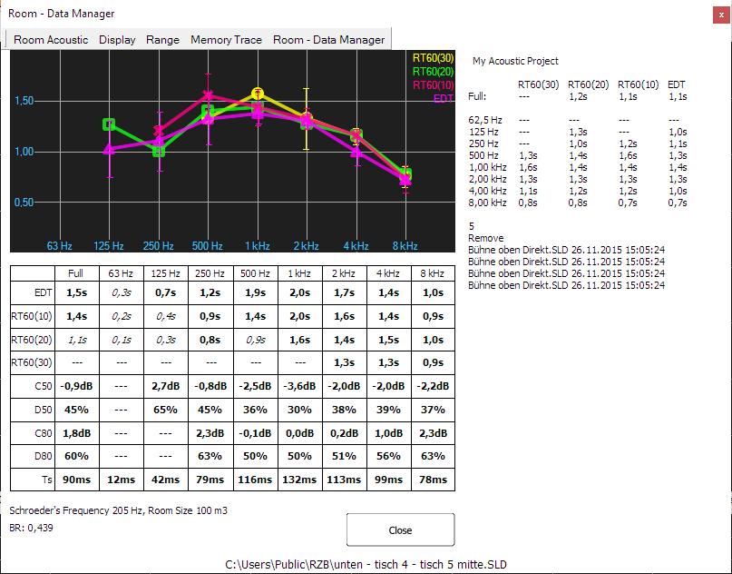
SATlive offers a room acoustic tool to calculate room – acoustic values using an impulse response. The quality of the results relates to the quality of the impulse response used, so you should take care to create a good impulse response (use long impulse responses). The room-acoustic tool is invoked in the menu Tools (see page 77).
The traces for the reverberation times are shown at the top. Below the graphic there is a table containing the numerical values of the reverberation times and other room – acoustic parameters (see page 51 for details).
The room – data manger (see page 53) on the right side of the window allows you to easily average different measurements of the same room.
The tool starts using the last selected calculation settings. See page 34 for details.
You can modify the settings using the menu entry Configure Schroeder Trace in the menu entry Room Acoustic.

The views of the acoustic window
The acoustic window supports two different modes.
- In the Single trace mode mode different acoustic values, all based on the same measurement (the so called master – trace), will show in the display and in the numeric display.
- Using the Multi trace mode you can display a certain room-acoustic value of more than one trace.
Use the entry Show multiple traces in the menu Display (see page 46) to toggle between the two views.

Managing Traces in Multi Trace Mode
Using the multi – trace mode you can display up to eleven different traces in the display.
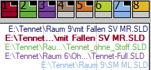
You can control the visibility of the main – trace, of the memory – trace and of the room – data trace in their menus.
The control of the eight trace latches is similar to the quick – trace handling (see page Error: Reference source not found for details) and can be done using the popup menu.
- To assign the main – trace to a trace – latch use the entry Copy to Trace – Memory in the menu Main – Trace.
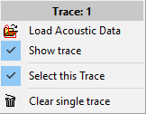
- Use the entry Load Acoustic Data to load stored acoustic data into the trace – memory.
- Show trace toggles the visibility of the trace. You can also click on the upper area of the icon to toggle the visibility of the trace.
- The entry Select this Trace brings the trace to the front and shows its values in the lower area. The name of the trace will show in the header. Click on the lower area of the icon to select the trace using the mouse.
- The entry Clear single trace will remove the acoustic data from this trace.

The menu Room – Acoustic
This menu is located in the menu – bar of the Acoustic Window.
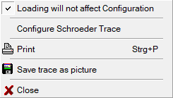
- Loading will not affect Configuration select this entry to use the current settings of the Schroeder – trace. Otherwise the settings assigned to the file recalled will be used.
- Configure Schroeder Trace opens the configuration window for the calculation. See page 34 for details about this window. You can open this window also by a mouse click onto the status – bar at the bottom of the window. The status – bar shows the currently selected parameter of the calculation.
- Print prints the room acoustic parameter and the reverberation graph.
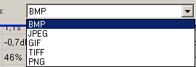
- Save Trace as Picture save the graphic to a file. You can select the kind of picture you want to save it to in the selection on the bottom of the save dialog.
- Close closes the window and returns to the impulse-response module.

The menu Display
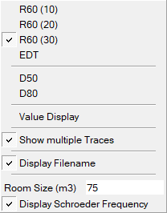
- Use the entries at the top this menu to select the traces to show in the display area. In the single trace mode (see page 44) you can select any combination of traces for the display. Using the multi trace mode (see page 44) allows you to select only one type of acoustic data at a time. See page 51 for a close description of the different types of acoustic data.
- Value Display open the value – display menu to configure the value – display area located in the lower half of the window.
See page 47 for a more detailed description of this menu.
- Show multiple Traces use this setting to toggle between the single trace and the multi trace mode of the acoustic window. See page 44 for more details.
- Display Filename shows the name of the file related to the acoustic values. Otherwise the description of the file is used.
- Schroeder Frequency
  - The Schroeder Frequency is a threshold frequency based on the size of a room and on its reverberation time.
Below of that frequency you’ll need to calculate the acoustic using single frequency waves, above the broadband approach will fit.
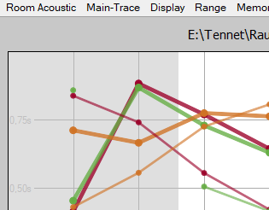
  - Room size enter the room size used for the calculation of the Schroeder's frequency. You can change the units used in the Setup → Features window. (see page Error: Reference source not found for details).
  - Display Schroeder Frequency marks the area below the Schroeder Frequency in the display.

The menu Value – Display
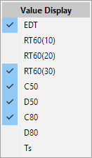
This menu configures the data – display in the lower half of the acoustic window.
You can access the menu either via the entry Value Display in the menu Display or by a clicking on the data – display area using the right mouse – button (popup menu).
Check the values you want to be displayed.
The height of the data – display will adapt to show all values selected.
See page 51 for a detailed description of the values available.
SATlive stores your selection.

The menu Range
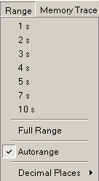
Use the menu Range in the top menu bar to change the vertical range.
- You can choose the desired vertical display area by selecting one of the topmost entries in this menu.
- If you click on Full Range, then SATlive adjusts the display in way that all of the values are shown.
- If you enable the Autorange option, then the vertical range is adjusted to keep all of the traces displayed in the display area. This acts similar as the Full Range function, but this option adjusts the display range every time the values to display change. This setting is memorized and will be restored when you re-enter the room-acoustic tool.
- Use the Decimal Places sub-menu to adjust the display of the room-acoustic values in the lower half of the window according to your needs. Just select the desired amount of decimal places from the sub-menu.
  - No Decimal Place: The values show as whole numbers: 8 s
  - One Decimal Place: One decimal place is shown: 7.9 s
  - Two Decimal Places: Two decimal places are shown: 7.92 s
  - Three Decimal Places: The highest amount available here: 7.921 s

The menu Main – Trace
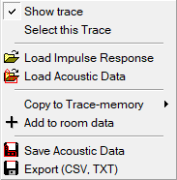
Use this menu to configure the display of the main trace.
- Show trace controls the visibility of the trace.
- Use Select this Trace to show the room acoustic values of this trace in the area below the display.
- Load Impulse Response loads an impulse – response from a file and converts it into acoustic data.
- Load Acoustic Data opens room – acoustic data stored in a file.
- Copy to Trace -memory will store a copy to one of the eight room data latches.
Select the target from the sub – menu of this entry.
- Add to room data will add the acoustic values of the main – trace to the current room – data project (see page 53).
- Save Acoustic Data saves the results of the acoustic calculation based on the main – trace in a SATlive specific format.
You can use the Memory Trace menu or the popup of the memory traces in multi trace mode (see page 44) to load and display a saved acoustic-data file.
- Export (CSV, TXT) allows you export the results either as CSV (comma separated values), which is used for spreadsheets like Excel®, or as a plain text file. You can choose the desired type of file in the lower right area of the save – dialog window.

The menu Memory Trace
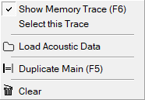
You can load a saved result of the acoustic calculation into a second trace, which is called memory trace.
You can use the memory – trace in both views (see page 44) of the acoustic – window.
- Show Memory Trace toggles the visibility of the memory trace. Hotkey F6.
- Select this Trace (available only in multi – trace mode) brings the memory – trace to the front and shows its values in the bottom area.
- Load Acoustic Data opens a dialog where you can select the set of acoustic data which you want to use as the memory trace data.
- Duplicate Main copies the data of the current display to the memory trace.
The shortcut for this function is F5.
- Clear empties the memory trace.
Hints:
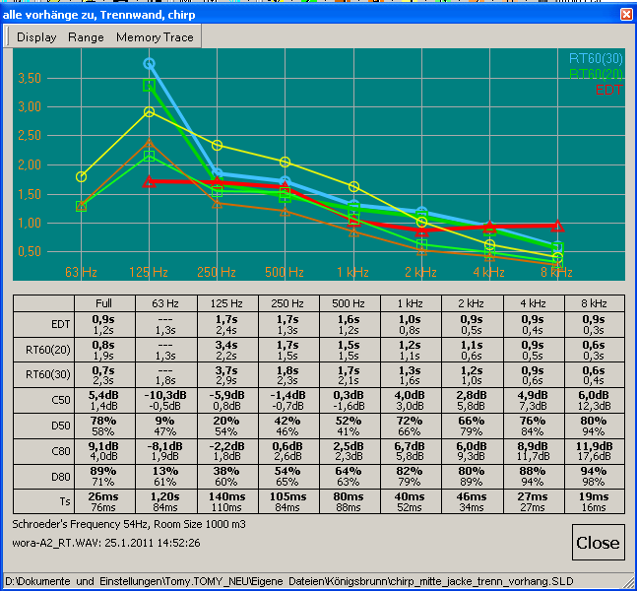
- In the single trace mode of the acoustic window (see page 44) the values of the memory trace show as thin lines and its values are displayed using default font, while the values of the main impulse response will show as thinker lines and the values will displayed using a bold font.
- If valid acoustic data has been loaded then the file name is shown in the lower left area of the acoustic-calculation window.

The menu room – data
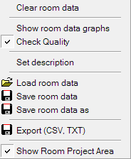
This menu controls the room – data manager. See page 53 for details about the room – data manager.
- Clear room data: Clear all data in the current room – data file. See page 53 for details for the room – data file.
- Show room data graphs: Select this entry to show the averaged values of the traces added to the current room – data set. The display will show the averaged values and their standard deviation is indicated by vertical bars.
- Check Quality: If checked SATlive will verify the quality of the values and will only add values with good quality to the room data file.
- Set description: This entry opens an editor window where you can edit the description of the current room – data set.
- Load room data: Use this entry to load a previously saved room – data set from a file.
- Save room data: This entry saves the current room – data set using the filename used during the previous loading or saving. It is enabled only if the current room – data set has either been saved or loaded before.
- Save room data as: Use this entry to save the current room – data set to a file. This entry opens a file – selection window where you can select the folder and name to store the data to.
- CSV Export: Use this entry to export the current room – data set as CSV data. You can import CSV data easily into spreadsheets, like Excel ©.
After the selection of the folder and name for saving the file to, a window will show up where you can edit the parameters and the values used for the export. Note your settings, because the spreadsheet – software might ask for it.
- Show Room Project Area: Use this entry to show or hide the Room – Project (see page 53) area. The area will show up automatically when you open a room – project.

Room – Acoustic Parameters
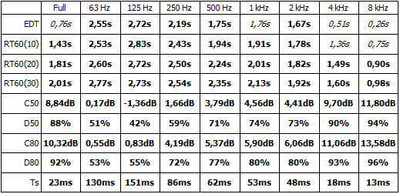
The numeric results of the room acoustic calculation are shown in a table below the graphic display of the reverb – time values. The values are calculated for the whole frequency range and for octave-band filtered signals.
You can use the menu Value Display (see page 47) to hide the entries you’re not interested in. The height of the area will adapt to your selection.
- RT60 or reverberation time is the most common value used in room acoustics.
It shows the calculated time that a sound would need to decay to 60dB below it's initial level. This time is calculated based on a certain range of the decay trace, depending on the signal to noise ratio available.
  - RT60(30) is based on the slope between -5dB and -35dB.
  - RT60(20) is based on the slope between -5dB and -25dB.
  - RT60(10) is based on the slope between -5dB and -15dB.
  - Optimum values for the RT60 depend on the size of the room. The literature suggests approx 2 seconds for music and approx 1 second for speech.
  - The correlation of the result, is used to determine the quality of the calculation.
A value shown in italic font indicates a low correlation. You can display the correlation of each value by placing the cursor on an entry and holding the left mouse button down.
- EDT means Early Decay Time, which is another reverberation time. This time is calculated using the range from 0dB to -10dB. Under normal circumstances the EDT is the reverberation time that you 'feel' in a room, while the RT60 is a more technical value used for calculations. For music the EDT value should be approx 2.2 seconds.
- C50 and D50 are values which relate the energy arriving in the first 50 milliseconds compared to the whole energy (D50) or compared to the energy arriving after the first 50 milliseconds (C50). This values are useful hints for intelligibility. Values greater then 0dB (C50) or 50% (D50) indicate a good intelligibility.
- The calculation of the C80 and D80 values is similar to the calculation of the C50 and D50 values, with the difference that they relate to the energy arriving in the first 80 milliseconds. This values are used for judging the musical sound of a room. A good music reproduction is archived if the C80 value is between -3dB and +1dB, which is the same as a D80 value of around 50%.
- The center time marks the center of gravity of the energy-time area. It is a measure for position of the main energy in time. Its value should be below 80 milliseconds for speech and between 100 and 150 milliseconds for music reproduction.
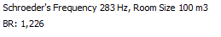
- The Schroeder's frequency depends on the room size, which can be set in the display menu (see page 46) of the room-acoustic window. You need to take care of discrete room – modes only at frequencies below the Schroeder's frequency.
The Schroeder's frequency is shown in the status – bar at the bottom of the room-acoustic window.
- The Bass – Ratio (BR) shows the relation of the sum of the RT₆₀₍₂₀₎ values for the 125Hz and 250Hz band related to the sum of the values for 500Hz and 1kHz.
This value is an indicator how “boomy” the room will sound. Values above one will indicate intelligibility problems.
Hint:
- You can use the Decimal Places sub-menu in the range menu (see page 47) to adjust the display of the values.
- You can display the regression – lines for the full – range Schroeder – plot using the Configure Schroeder Trace window (see page 34).

The room – data manager
This tool is attached to the room – acoustic window (see page 43).
It eases the averaging of different measurements of the same location. It supports saving and loading of room – data sets as well as export and display of the results.
The tool averages the four reverb – time values (RT60₁₀, RT60₂₀, RT60₃₀ and ETC).
The so called r – value, which is an indicator for the quality of the approximation used for the calculation of the values can be used as a threshold for the use of a specific value.
The visibility of this area is controlled by the Show Room Project Area setting in the menu Room Data Manager (see page 50). The area will show up automatically when you load a room – project.

Adding data
To add the values of a measurement to the room – data set, load the impulse – response into the room – acoustic window using the load command located in the menu room – acoustic (see page 45 for details about this menu). After that, add it to the room – data set using the entry Add to room data in the menu room – acoustic (see page 45).
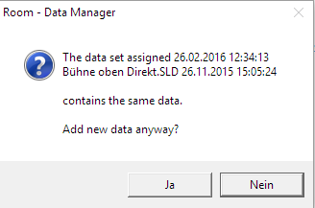
If the data you want to add match a data – set still in the room – data set then SATlive will show a confirmation window, otherwise the data will be added directly.

Display of the data
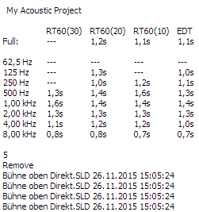
The averaged values are shown at the top of the right area. SATlive shows the description of the impulse – responses used for the averaging. Depending on the Check Quality setting in the menu Room – Data Manager (see page 50) values are shown only if the quality indicator (‘r – value’) of the values is over the quality – criteria.

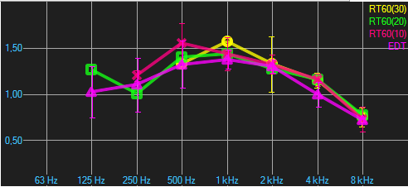
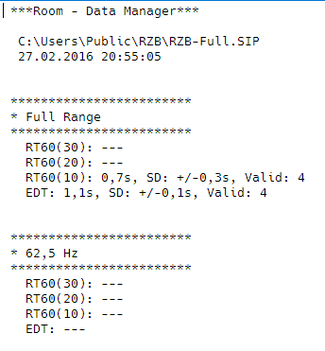
If the option Show room data graphs is enabled in the menu Room – Data manager (see page 50) then the calculated traces will show in the display area on the upper left, with the standard deviation shown as a vertical bar.
The CSV file or the text file generated by the room – data manager contains all numerical values.

Load impulse – response from a file
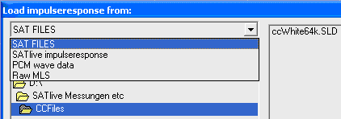
The Load Timefile function opens a file selection window, where you can select the desired type of file from the selection box at the upper left.
- SAT Files new SATlive file type (*.SLD).
- SATlive Impulse response older version of time data files.
- PCM Wave Data impulse response saved as pcm wave file.
- Raw MLS imports a pcm file, that containing recorded audio from a MLS sequence.
Hints:
- The function's popup menu contains a list of the most recent used files.
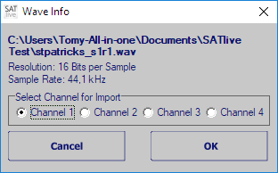
- When you open a pcm (‘wav’) file, a window containing details about the file will show up. If the wave file contains more than one channel, you can choose the channel to use in this window, too.

Set the parameters of the current measurement
The parameters of the measurements in the impulse – response module are set in an additional setup window.
There are different ways to open this setup window:
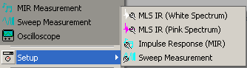
- In the simple menu layout the setup is located in the popup menu of the start measurement button in the bottom menu bar. The setup is located in the sub menu Setup.
- In the complex menu layout you find a dedicated bottom for the setup right to the start measurement bottom in the top menu bar. The button's icon varies depending on the currently selected measurement. There is no setup button if the oscilloscope type measurement is selected.
- Use the button F9 to invoke the setup window of the current measurement.
- When you edit user macros, then the button Edit in the area Impulse Response invokes the setup.
- The menu Setup at the top contains the setup for the current measurement.
Hint:
A closer description of the measurements can be found starting at page 58 in this document.

Complex Compensation
SATlive contains tools for examining the impulse response.
Therefore a need for a calibration mechanism comparable to the calibration for the FFT arises for the impulse response only measurements.
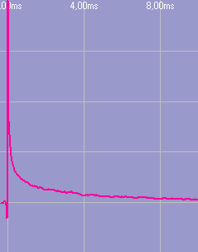
This is the reason for complex compensation, which is a compensation mechanism for the impulse response using a flat reference file with the same settings (size and samplerate) to compensate the influence of the measurement equipment like the preamp and the audio interface and, if needed, also to remove the filtering applied to the measurement signal.
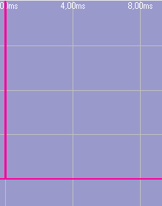
- To perform a complex compensation you must first create a complex compensation file. This is done by performing the same measurement with just a wire, i.e. with the output directly linked to the input.
- Then save the impulse response using the Save as Complex Compensation function.
- Now open the measurement's setup window, select the complex compensation file you saved in the last step, and activate the use of the complex compensation by checking the USE option. To check the complex compensation just repeat the measurement. It should result in a perfect impulse response.
Hints:
- You can use the complex compensation to compensate the influence of 'colored' measurement signals like the pink MLS signal.
- You can activate and assign complex compensation files in the macro setup.
- You can combine the complex compensation with the calibration of the FFT. But be careful not to overcompensate.

Measurements in the Impulse – Response Module

MIR Measurement
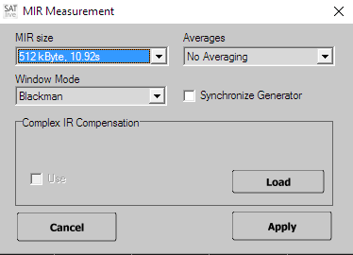
The MIR Measurement is a measurement based on comparison of two channels, like the Dual Channel FFT. Opposite to the Dual Channel FFT, the MIR measurement will yield an impulse response.
Therefore there is no need to adjust the delay prior to measurement. In measurement's setup you can edit following settings:
- MIR Size select the length of the audio signal used to calculate the impulse response from. A higher number delivers a better result, but needs more time to perform.
- Window mode select the window applied to both input signals (measurement and reference) prior to the calculation. When the expected time delay between both signals is small related to MIR size, you should use the Flattop window. Otherwise rectangular window must be used, in order not to affect the impulse response.
- Synchronize Generator links the start/stop of the signal generator with the start and end of the MIR measurement.
- Averages select the amount of measurements to be averaged before the calculation of the impulse response.
- Complex IR compensation select the file used for the complex compensation. Check use if you want to apply the selected compensation file. See page 57 for details about complex compensation.
Hints:
- In order to improve the quality of the result you should increase the MIR Size instead of increasing the amount of Averages. If your measurement is spoiled by unwanted external noise, you should increase the amount of averages.
- MIR measurement is located in the impulse – response module, but it's connections differ from those used for the MLS measurements.
- To get a high quality impulse response, the reference signal must contain all the frequencies of interest. Using pink noise will produce the best results. When you use music it should contain a wide frequency range.
- You can use the shortcut F3 to select the measurement, the shortcut F4 to start and the shortcut F9 for the setup of the selected measurement.
- If you want to measure only the frequency response, you should use the transfer function measurement in the MAT Module which contains possibilities to validate the result and a continuous display.

MLS white
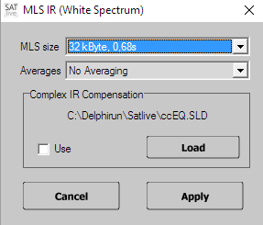
The MLS is a quick algorithm for the calculation of the impulse response.
It uses a special audio stimulation signal, called maximum length sequence, which has the same spectrum ('sound') as white noise.
The impulse response is calculated very quickly. One disadvantage of the MLS is the need for a special stimulation signal.
In the measurement's setup you can edit these settings:
- MLS size select the length of the MLS stimulation signal used. The Impulse response calculated from this measurement will have the same length.
- Averages select the amount of measurements to be averaged prior to the calculation.
- Complex IR compensation select the file used for the complex compensation feature. Check use to apply the selected compensation. See page 57 for details.
Hints:
- To improve the quality of the result you should increase the MLS Size instead of the amount of Averages. If your measurement is spoiled by external noise, you should increase the amount of averages.
- For room measurements you should prefer MLS pink (see page 61), which will improve the quality of the impulse response at lower frequencies.
- For the MLS measurement to work properly, one MLS stimulus is played prior to the measurement.
- On reverberant conditions the impulse response's size (set by MLS Size) should be at least similar to the reverberation decay time (RT₆₀).
- The MLS measurement's results can be affected by distortion and time variances of the measured system.
- You can use the shortcut F3 to select the measurement, the shortcut F4 to start and the shortcut F9 for the setup of the selected measurement.

MLS Pink
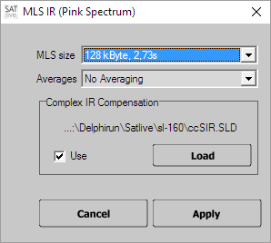
The MLS is a quick algorithm for calculation of the impulse response. It uses a special audio stimulation signal, called maximum length sequence, which has the same spectrum ('sound') as white noise.
White noise contains the same energy for the same frequency range (i.e. the same energy in the range from 50 Hz to 100 Hz as in the range from 5050 Hz to 5100 Hz), so you'll notice a lot of high frequencies when listening to a white noise signal.
To adapt this signal to human hearing, a so called 'pink' filter is applied, which leads to the same energy content for each octave. (now the range from 50 Hz to 100 Hz contains as much energy as the range from 5.000 Hz to 10.000 Hz).
This signal is much more suitable for acoustic measurements, like speaker or speaker – room measurements.
In a MLS Pink measurement, you have to remove the filtering after the measurement to get the correct result. Otherwise the result contains the frequency response of pink filter added to the measured impulse-response. You can use either the Complex Compensation (see page 57) or the calibration (see page Error: Reference source not found) to remove the effect of the pink – filter.
The measurement setup allows you to edit these settings:
- MLS size select the length of the MLS stimulation signal used. The impulse response calculated from this measurement will have the same length.
- Averages select the amount of the measurements to be averaged prior to the calculation.
- Complex IR compensation select the file used for the complex compensation. Check use to apply the selected compensation to the impulse response. See page 57 for details about complex compensation.
Hints:
- To improve the quality of the result you should increase the MLS Size instead of increasing the amount of averages. If your measurement is spoiled by external noise, you should increase the amount of averages used.
- For the MLS measurement to work properly, one sequence has to be played prior to the measurement. Therefore a non averaged MLS measurement needs twice the time of the impulse response to perform.
- On reverberant condition the impulse response's size (set by MLS Size) should be larger or at least similar to the (expected) reverberation decay time (RT₆₀).
- The MLS measurement's results can be affected by distortion and time variances of the measured system.
- You can use the shortcut F3 to select the measurement, the shortcut F4 to start and shortcut F9 for the setup of the selected measurement.

Sweep measurement (impulse response)
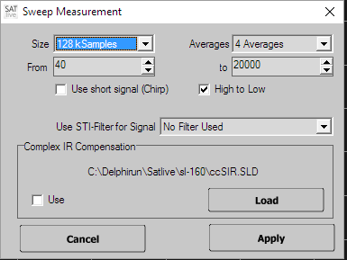
The Sweep Measurement is a measurement based on the comparison of two channels, like the Dual Channel FFT, using a swept sine as the excitation signal.
The measurement will yield an impulse response.
Therefore there is no need to adjust the delay prior to the measurement.
In the measurement's setup you can edit the following settings:
- Size the length of the impulse response. A higher number delivers a better result, but needs more time to perform. The sweep-signal length is set to half the length of the impulse response, if Use short signal (Chirp) is not activated.
- Averages the amount of measurements to be averaged before calculation of the impulse response.
- From the starting frequency of sweep, i.e the lowest frequency played.
- To the ending frequency of sweep, i.e. the highest frequency played.
- Use short signal (Chirp) shortens the time used for the sweep signal, so that only a real short sound is audible. This setting does not affect the length of the impulse response calculated.
- High to Low use this setting to run the sweep from the high frequency down to the low frequency.
- Use STI – Filter for signal use this option to apply a digital filtering to the signal generator. This makes the energy contribution more similar to the contribution of energy in speech. You should use this filter only if you want to perform a STI --calculation (see page 40) using the impulse – response measured.
- Complex IR compensation select the file used for the complex compensation and enable it. Refer to page 57 for details about the complex compensation.
Hints:
- To improve the quality of the result you should increase the Size instead of increasing the amount of the averages. If your measurement is spoiled by unwanted external noise, you should increase the amount of averages used.
- The Sweep measurement is located in impulse response module, but its connections differ from those used for MLS measurements.
- You should use the STI – Filters only if you want to calculate the STI value, because the filter decreases the noise immunity of the measurement, especial at low and high frequencies. This is a wanted behavior for the measurement of the STI value, because intelligibility is affected by external noise also.
- You can use the shortcut F3 to select measurement, the shortcut F4 to start and the shortcut F9 to invoke the setup for the selected measurement.
- If you want to measure the frequency response, you should use the MAT Module, because of it's possibilities to validate the result.
See page Error: Reference source not found for more details of the transfer – function measurement.

Oscilloscope
The oscilloscope measurement in the impulse – response module displays the signal on the inputs directly.
On the right side you’ll find the control section.
Use the Oscilloscope button to start or to freeze the display.

The channel settings
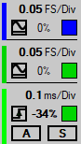
At the top you can see the current settings for the measurement input, and below you find the current settings for the reference input. The color on the left indicates the color of the trace in the display.
The upper line shows the current resolution, which can be changed in the settings window (see page 67).
The lower line contains three different areas.
- The area on the left shows the AC option. With the AC option enabled SATlive will try to remove the steady part of the input signal (its DC component). Click on the symbol to toggle the mode. The icon indicates the current mode.
Please note, that most of the audio interfaces block DC signals at their inputs.
- At the center you can see the current vertical offset of the trace.
A click on this value will reset the offset to zero.
Use the settings window (see page 67) to set the vertical offset.
- Use the rectangle on the right to toggle the visibility of the trace. As long as the trace is visible the rectangle is filled with the color of the trace.

The trigger settings
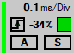
The lower area contains the settings for the trigger and time – base.
The upper line shows the current time – base setting. The time – base determines the horizontal range of the display.
Use the settings window (see page 69) to change the time – base.
The colored line at the left shows the current state of the trigger. A green line indicates that a trigger is available. Otherwise the line will show red color.
The lower area contains different settings:
- At the left you can choose whether triggering should occur when the signal rises above the threshold (rising edge) or when the signal drops below the threshold (falling edge). Click on the symbol to toggle the mode.
- At the center the current trigger – level will show. The trigger – level is the threshold used to trigger the display. The value shows in percentage of the height of the display. Click on this area to open the settings window (see page 67).
- The rectangle at the right indicates the trace selected as the source for the trigger. Click on the rectangle to toggle between both traces.
- The switch A activates auto – trigger. In this mode the display will redraw even if the input does not read the trigger threshold. This mode is also know as Free – Run.
- The switch S activates the single – shot mode. In this mode the display will redraw when the input first reaches threshold. Afterwards the display freezes until you click on a switch. Use this mode for impulsive signals like spikes or interference.

The settings window
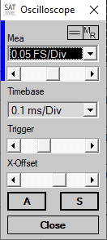
To invoke this window just click onto the upper line of each area.
The upper area allows the selection of the vertical resolution for the selected trace. The entry GND will show the trace as a straight line at the current offset value.
The line at the left indicates the color of the trace assigned. To toggle between both traces you can click on the label above the selection. The popup menu of the vertical offset setting contains a trace selection where you can choose the trace you want to edit.
The slider allows you to move the trace in vertical direction.
To zero the vertical offset, either choose the entry Center from the popup menu or click on the display of the current offset value at the center of the bottom line of each channel setting (see page 65).
The lower part of the settings window contains the time – base selection.
- The trigger slider, which contains a popup menu, sets the threshold of the trigger.
- You can set the source of the trigger signal and the kind of the trigger in the trigger settings (see page 66) in the area right to the display.
- Using the X – offset slider you can move the traces in the horizontal direction. Like the other sliders this slider also contains a popup menu.
- The switch A activates auto – trigger. In this mode the display will redraw even if the input does not read the trigger threshold. This mode is also know as Free – Run.
- The switch S activates the single – shot mode. In this mode the display will redraw when the input first reaches threshold. Afterwards the display freezes until you click on a switch. Use this mode for impulsive signals like spikes or interference.
All changes you’ll do in this window will immediately affect the display.
Use the button Close to exit the settings window.

The menu tools
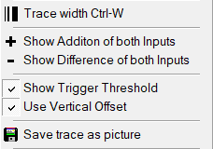
The menu Tool contains some settings and functions for the oscilloscope (see page 65). The popup menu of the trace – display area will contain the same entries except of the Trace – Width setting.
- Trace Width use this setting to toggle different line - width values for the display. You can also use the key combination Ctrl + W for this function.
- Show Addition of both inputs. This entry adds an other trace to the display, calculated as the sum of both traces. You can select this options only if both traces use the same vertical scaling.
- Show Difference of both inputs. This entry subtracts the ref – signal from the mic – signal and shows the result.
- Show Trigger Threshold. This setting will draw a horizontal line at the current position of the trigger level.
- Use Vertical Offset. With this option set, the trigger line in the display will draw using the vertical offset currently used for the input selected as trigger – source. Otherwise the trigger line will relate to the zero line of the display regardless of the vertical offset used for the display of the trace.
- Save trace as picture. This entry will show a saver – dialog window where you can choose the type and the file – name used to save a screenshot of the current display.

Files and Traces (Impulse response complex menu layout)
This menu is located in upper menu-bar.
- Load time data loads a saved impulse response. The popup menu contains a list of the recently used files. Opening an impulse response will destroy the currently displayed impulse response.
- Load time data into the second trace: load a saved impulse response into the second impulse response's trace.
- Save Impulse response saves the current impulse response to a file. You can save impulse response in different types of file.
- Trace width toggles the width of the trace. Shortcut Ctrl – W.

Save the Impulse Response
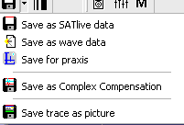
You can save the impulse response to different file types, which you find in the popup menu of the SAVE button.
- Save as SATlive data this is the default setting. The trace is saved containing all settings. If the show fileinfo when saving option in the Setup → Features window is enabled, the current settings are shown prior to saving the file. In this case you can edit the file's description.
- Save as Wave data saves the trace as a *.wav (windows pcm, mono) file.
- Save for praxis saves the impulse response readable for praxis (www.libinst.com) software. This great software allows a lot of post-processing, like waterfall display.
- Save as complex compensation saves the current impulse response as complex compensation data. See page 57 for details about complex compensation.
- Save trace as picture saves the upper display as a picture. You can select the picture's format from the file type selection box in the save menu.
Hints
- You can select the quality of the pictures at setup → features (See page Error: Reference source not found for details).
- Please note that SATlive will read only SATlive or PCM type files.

Automated Creation of the File – name
The IR module features automated creation of file – names and automated sequential saving, which speeds up the collection of measurements for acoustic analysis of a room.
This tool is also supported by the web – client (see page Error: Reference source not found for details).
Invoke the automation window in the pop – up menu of the trace display area (see page 74) by clicking the entry Automated File Name Creation.
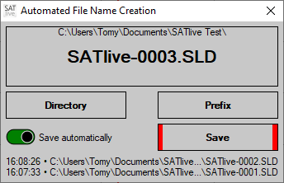
Use the button Directory to choose the directory where you want to place the files into.
Use the button Prefix to edit the first part of the filename.
The software will extent the prefix with a unique number.
The top area shows the directory chosen and the filename that will be used for the next saving.
The button Save allows you to manually save the current trace using the filename shown in the upper window. After saving the name will be updated.
Please note that you can save each trace just one time using this tool.
If the switch Save automatically is turned on (indicated by its green background), then SATlive will save the traces automatically directly after the end of the measurement. Afterwards the name will be updated.
The list at the bottom shows the path and name of the recently saved files, showing the time on the left and the most current file at the top.
Running this tool enables the remote control of the IR via the web – client (see page Error: Reference source not found).

Macros in impulse response module
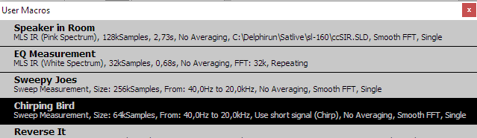
In SATlive a macro describes a measurement and it's post-processing performed in the impulse – response module.
SATlive features twelve different macros. The Macros one and two are directly assigned to the buttons Speaker/Roomand Direct / Equalizer
- To edit a macro, go to Setup → User Macros (see page Error: Reference source not found)
- You can start the first two macros with a mouse-click on the assigned buttons.
- The other ten macros can be accessed via the macro-list. The macro-list contains the first two macros as well.
- If you didn't run a macro before then a left mouse click on the button M shows the macro list.
- If you'd run a macro before then a left mouse click on the button M repeats the last used macro.
- You can open the macro-list using the popup menu of the button M.
- To run a macro from the list, just click on it's name or description with left mouse button.
- After the execution of a macro from the macro list, the macro's is assigned to the User Macro Button M. You can rerun the macro then by just clicking on the button. The other macros can be accessed via the button's popup menu.
- To get more information on a special macro, just click on it's name or description with right mouse button.

Perform a FFT using the current impulse response
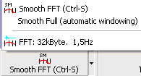
- In the simple menu layout this function is located in the lower menu-bar.
- In the complex menu layout, this function is located in the top menu area.
- FFT start the calculation of a FFT of the current impulse response's section which is shown in upper window, using the selected resolution. After performing the FFT SATlive changes to the FFT module. You can start the FFT using the shortcut F7, too. The resolution of the FFT can be selected from the popup menu of this button.
- Smooth FFT start a Smooth FFT of the current impulse response's section displayed in upper trace window. You can also use the shortcut F8. The function Smooth Full, which you find in the button's popup menu, extends the right border of the upper display before performing the smooth FFT in order to get enough valid data for calculation.

Trace Display options in the Impulse — Response Module
This options are located in the right menu-bar.
- Windowing toggles the application of the window selected prior to the FFT.
The window will always be a half window, i. e. it is only applied to the right half of the upper window, so avoiding spoiling of the peak, which should be in the left half.
See page 27 for details about windowing in the IR module.
- Lock the Window Avoids changing the selected region in the upper window when you run a macro. This could be helpful if you want to compare absolute phase values which always refer to the left window border.

Windowing in impulse response module
These options are located in the right menu area.
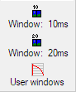
- Window 10ms applies a 10ms window, starting at 400usec before the peak. Shortcut: CTRL – 1.
- Window 20ms applies a 20ms window, starting at 400usec before the peak. Shortcut: CTRL – 2.
- User windows opens the User Window settings (see page 28), where you can either edit and apply preset windows or define the parameter of the window manually.

Cursor modes
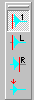
These options are located at right menu area (only in the complex menu-layout) and they are also present at trace display's popup menu.
These options select how SATlive reacts when you click on the impulse response's trace using the left mouse-button.
- Set Cursor (Default) Set the cursor on the mouse click's position. You can also use the shortcut C to select this option.
- Cut left of Click Set the left border of the upper window to the click's position.
- Cut right of Click Set the right border of the upper window to the click's position
- Set Cursor on Peak The cursor is moved to the point with the highest absolute value. This action is enabled only if the Set Cursor mode is selected. You can also use the shortcut Shift + P to perform this action.
Hint:
- You can perform these options in both, the upper and the lower, trace displays.

Impulse response trace's popup menu
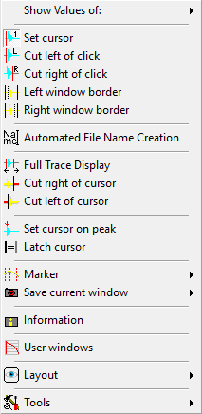
Click on the impulse response's display with the right mouse-button to open this popup menu.
- Show values of select the trace for cursor readout. You can select only traces currently showing in the display.
- Set Cursor set the cursor on the position of the mouse-click. You can also use the shortcut C to select this option.
- Cut left of Click set the left border of the upper window to the click's position.
- Cut right of Click set the right border of the upper window to the click's position.
- Left window Border see page 25 for details.
- Right window Border see page 25 for details.
- Automated File Name Creation opens a window supporting automated file – name creation. See page 70 for details.
- Full trace display see page 26 for details.
- Cut left of Cursor the left border of the upper window is set to the cursor's current position. This action is enabled only if the option Set Cursor is selected.
- Cut right of Cursor the right border of the upper window is set to the cursor's current position. This action is enabled only if the option Set Cursor is selected.
- Set Cursor on Peak the cursor is moved to the point with the highest absolute value. This action is enabled only if the Set Cursor mode is selected. You can also use the shortcut Shift-P to perform this action.
- Latch Cursor saves the cursor's current position as a reference. If a cursor is latched, the distance between the cursor's current position and the latched cursor's position will show above the display – area. This action is enabled only if the Set Cursor mode is selected. The shortcut for this function is D.
- Marker place a marker on the current cursor position or show the delay – matrix. See the marker section at page Error: Reference source not found of this document for details.
- Save current window save the current border positions of the upper window to a user defined window preset.
- Information show information about the current trace. You can edit the trace's description in the information window.
- User Windows open the editor for the user – windowing. See page 28 for further details.
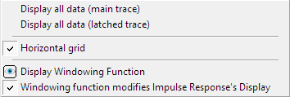
- Layout use the entries of this menu to control the display of the impulse – response.
  - See page 36 for details about the Display all data options.
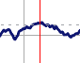
  - Horizontal grid shows a dashed horizontal line at the amplitude – value at the current position of the cursor.
  - Display Windowing Function toggles the visibility of the currently selected windowing function. See page 27 for details.
  - Windowing function modifies Impulse Response’s Display check this setting if you want to see the influence of the current windowing function on the impulse response. See page 27 for details.
  - Hint: You can set the transparency of the quicktraces in the quicktrace main menu.
- Tools shows the tools menu (see page 77) containing more options and functions.

Impulse response Menu bar simple Layout
If you’ve chosen the simple menu layout then a smaller amount of buttons is displayed. You can access many functions using a popup menu or the menu Tools.
- Room/Speaker starts the macro Speaker in Room.
- Direct/Equalizer start the macro Direct Electric.
- User Macros show the user macro list to choose a macro from. After the execution of a macro the executed macro is assigned this button. See page 71 for details.
- Start selected measurement you can select the type of the measurement to perform in the button's popup menu. The button's popup menu allows you to invoke the setup window for the different types of measurement. You can use the shortcut F3 to select the type of the measurement, the shortcut F4 to start the selected measurement and the shortcut F9 to invoke the setup window assigned to the selected measurement.
- Smooth FFT perform a Smooth FFT of the impulse response's selection shown in the upper window and then changes to the FFT module.
The button's popup menu contains the function Smooth Full, a smooth FFT with an automatic movement of the right border, and a 32kByte long FFT. You can use the shortcut F7 for the FFT and the shortcut F8 for the Smooth FFT.
- Tools more functions and options for the impulse — response module. See page 77 for details.
Hints
- You can edit the user macros at Setup → User Macros.
- Using the option Start measurement on selection at Setup → Measurement you can select if the measurement starts when you select another kind of measurement, or if you need to start the measurement with a click on the button or the shortcut F8.

Menu Tools in the Impulse — Response Module
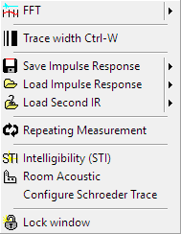
You can invoke this menu either using by clicking on the Tools symbol in the main menu bar or via the trace display's popup menu.
- FFT perform a FFT of the part of the impulse response in the upper window using the selected resolution. After performing the FFT SATlive changes to the FFT module. You can start the FFT using the shortcut F7, too. The resolution of the FFT can be selected in the popup menu of this option.
- Trace width toggle the width of the current trace. You can use the shortcut Ctrl + W, too.
- Save the impulse response save the current impulse response. You can save the impulse response to different types of file. See page 69 for details.
- Load impulse response load an impulse response. The popup menu contains a list of recently used files. This overwrites the impulse – response currently shown.
- Load second IR load an impulse response to be used as second trace.
- Repeating Measurement if is option is selected the measurement and the post-process are repeated until the measurement is stopped by the user.
- Intelligibility display the Speech Transmission Index (STI) calculated using the current impulse response. See page 40 for details.
- Room-acoustic open the room acoustic parameters window using the current impulse response. See page 43 for details.
- Configure Schroeder Trace opens the Configure Schroeder Trace window (see page 34) to set the parameters used for the calculation of the Schroeder Trace.
Because the Room – Acoustic values (see page 51) are based on the Schroeder trace, this setting will also affect those values..
- Lock window fixes the size and position of the selected part of the impulse response. The selected part is used for the calculation of the FFT. Use this setting if you want to compare time related values (like the phase – trace) in the FFT display.

