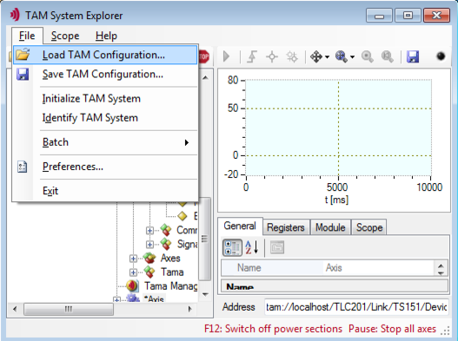  Figure 1: Load TAM configuration menu item |  | 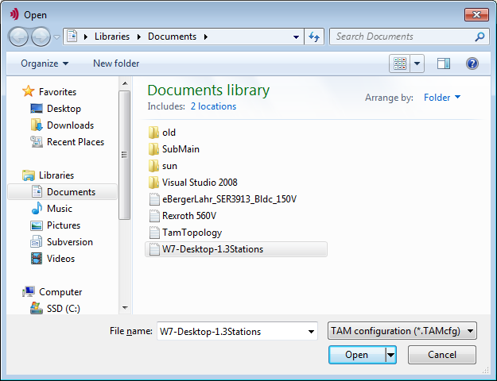Figure 2: Windows load file location browser
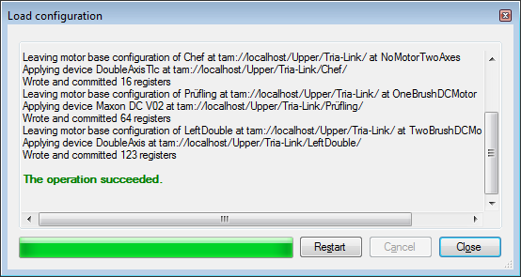
Figure 3: Configuration download progress window

When a TAM Configuration is loaded, the configuration is assigned to the physically existing stations according to the following scheme:
- If the name of a station in the tree does uniquely match with the name of a station in the configuration, the configuration of the station is assigned by name.
- If the station name does not match or is not unique, and the serial number of the device does match, the configuration is assigned by serial number.
- Stations that can't be assigned by name or serial number are assigned by station type, If a unique assignment according to the station type is possible,
- If at this point there are still devices which are not assigned, the Resolve TAM configuration dialog is opened (Figure Error: Reference source not found).
  - The dialog lists all stations available in the configuration at the left column of the table.
  - With the pull down menu in the right column a (not jet assigned) station from the TAM Topology Tree can be assigned to the configuration.
  - If the station does not exist in the current tree, select <mark for removal>.
  - To identify the target station, use the serial number or use the blink button. The blink button will cause a red blink of the axes LED and system status LED.

