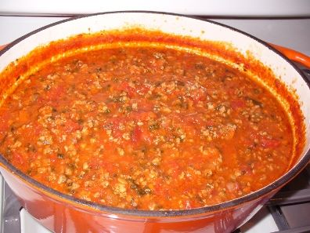  Ragu Bolognese  December 2020 |  | Ragu Bolognese  December 2020
Ragu Bolognese  December 2020 |  | Ragu Bolognese  December 2020

