

Functions, Menus and Settings
Version 1.70

Version 1.70.60
© Dipl.- Ing. (FH) Thomas Neumann 2000-2020

Contents
Signal generator 6
Set the output level 6
The menu of the signal-generator 8
Frequency 9
Output signal selection 10
Swept sine (Sweep) / Sweep (Inv) 11
The setup window 11
Sweep Presets 11
Bandpass – filtered Pink-Noise 12
Setting the range for the filter 12
Signal Impulse 13
The configuration window 13
Available Impulses 14
The WAV – Player 16
The control window of the Wav – Player 16
VU Meter 17
Start the output signal 18
Level Display 18
The Tracemanager 20
Single traces 20
The popup menu of the trace – name display area 21
Master Trace 22
Global functions 22
The menu Import 23
Offset, Color and Smoothing 24
Weighting and averaging 25
Example 25
Using Averaging 26
Setup Weighting 26

Swept sine (Sweep) / Sweep (Inv)
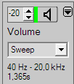
The swept sine is an output signal whose frequency increases or decrease continuously covering a given frequency range.
Select the swept sine signal in the signal generator's window from the output signal selection. The information area below the signal-type selection shows the parameters currently in use. To change the parameter, open the setup window by clicking on the information area. The sweep (Inv) signal will start at the highest frequency and run down to the lowest frequency.

The setup window
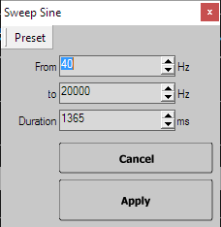
- Presets assigns the current settings to a preset or recall settings from a preset
- From the frequency at the start of swept sine
- To the frequency at the end of swept sine
- Duration the time in milliseconds used for one complete sequence
- Apply saves the changes and close the window
- Cancel discards the changes and close the window
Hint:
These settings do not affect the signal used for the sweep measurements in the impulse-response module.

Sweep Presets
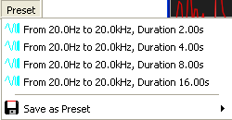
In the swept sine setup window you can assign the current settings of the sweep signal to one of the four presets, or you can recall one of the presets. To invoke a preset just select it from the popup menu available in the Preset menu of the sweep setup window. To save the current settings into a preset, select the preset to store to in the sub menu Save as preset in the popup menu of the button Preset at the top of the sweep setup window.

Bandpass – filtered Pink-Noise
The bandpass – filtered pink-noise is a signal which contains energy only in a certain range. The energy in the output signal is concentrated on that range, which is helpful in situations with high noise levels.
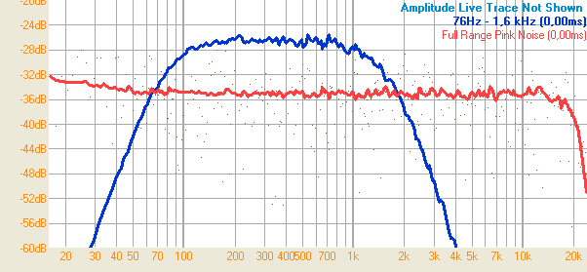
The red trace shows the default pink-noise signal, the blue trace a bandpass-filtered pink-noise with a range from 76Hz to 1.6kHz, with the same level setting.

Setting the range for the filter
There are different ways to set the filter range for the bandpass – filter used:
- Select the frequency range using the frequency – range tool (see page Error: Reference source not found) and use the Use selected Range for Bandpass entry in the popup menu of the signal – generator (see page Error: Reference source not found).
- Select the frequency range using the frequency – range tool (see page Error: Reference source not found) and double-click on the frequency-range display below the output-signal selection.
- Choose one of the most recently used filter settings shown on the bottom of the popup menu of the signal – generator (see page Error: Reference source not found).

