Bug 123009
LibreOffice 6.3 Impress running on Windows 8.1 platform with OriginalWinwickPassvideov4LO614videosetof3finalslide1click-slides31,68,97-Auto5s.odp file running Slide show from first slide Click ton the first slide to automatically run the presentation which ran through until slide 95 when it stopped and the following messages displayed to which I have Screen Printed each step as follows:
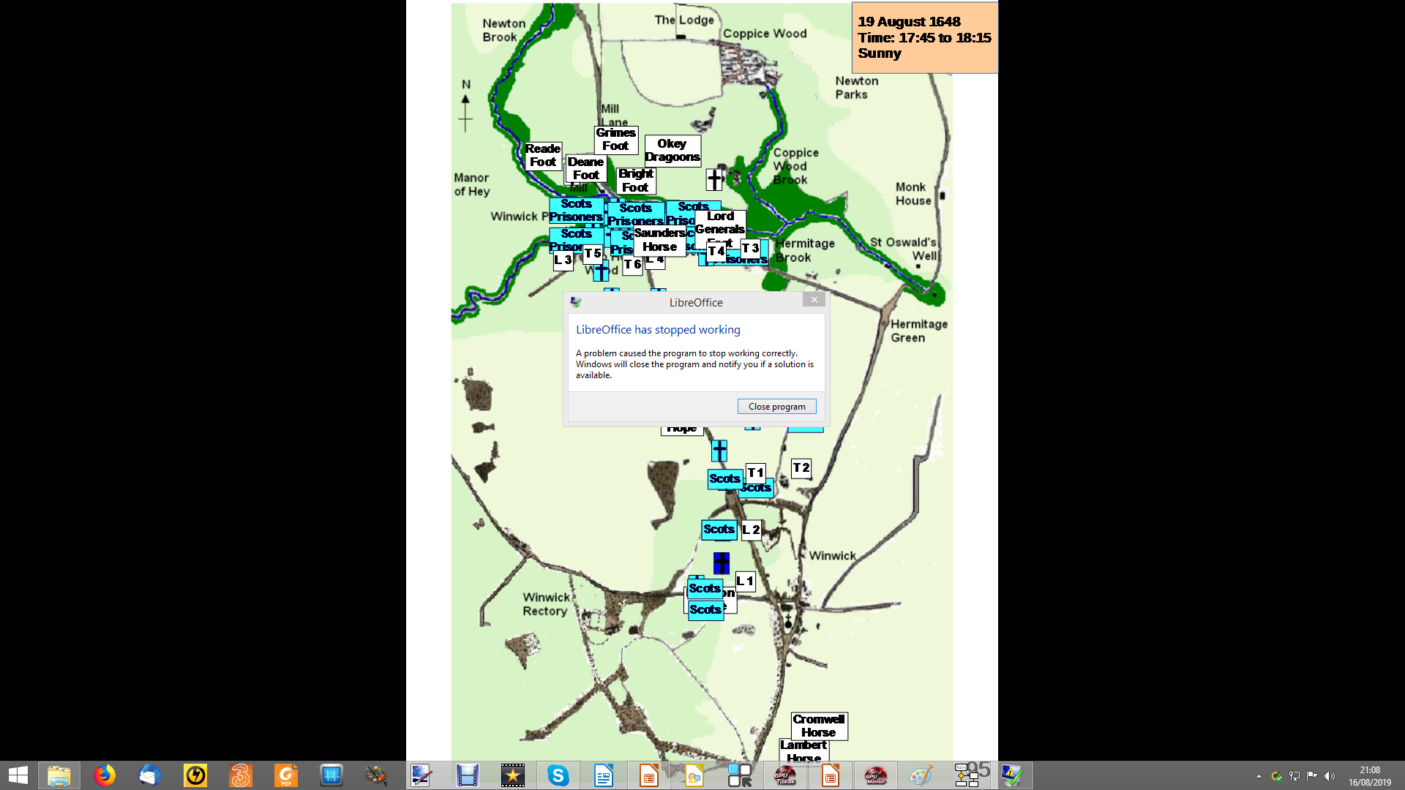
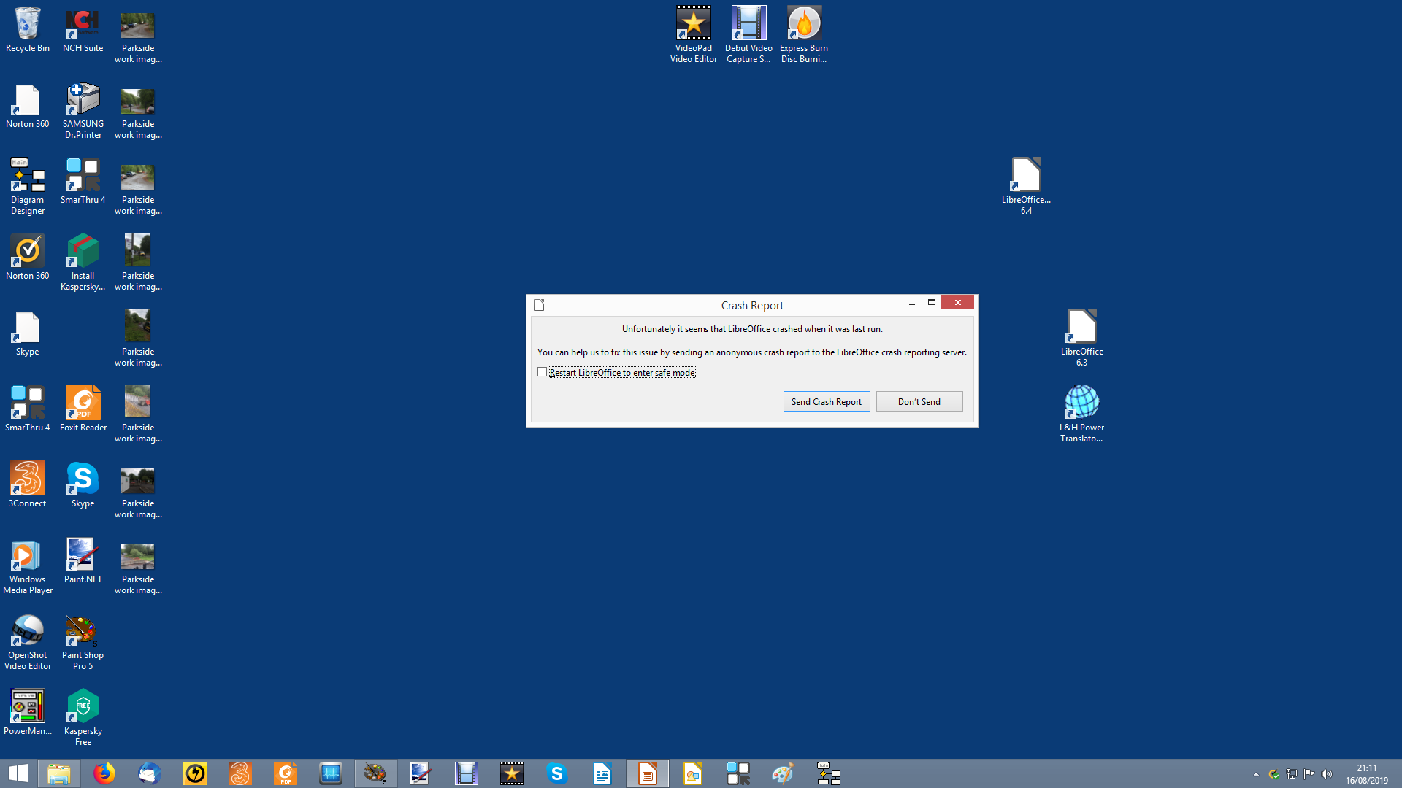

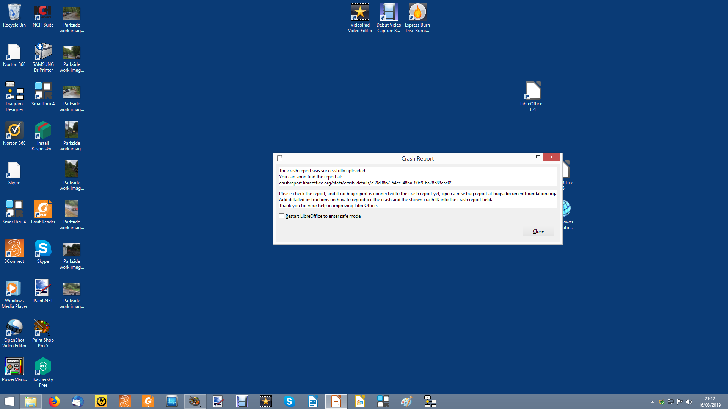

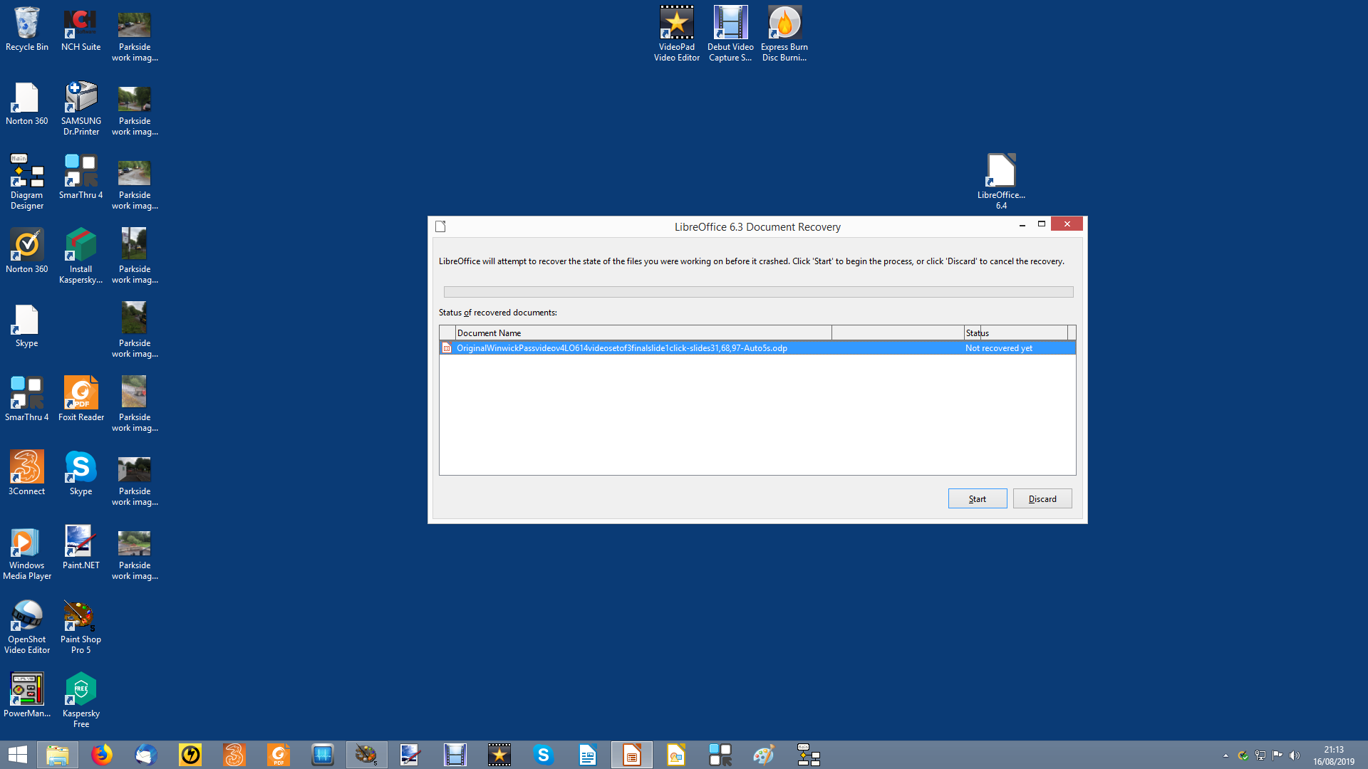

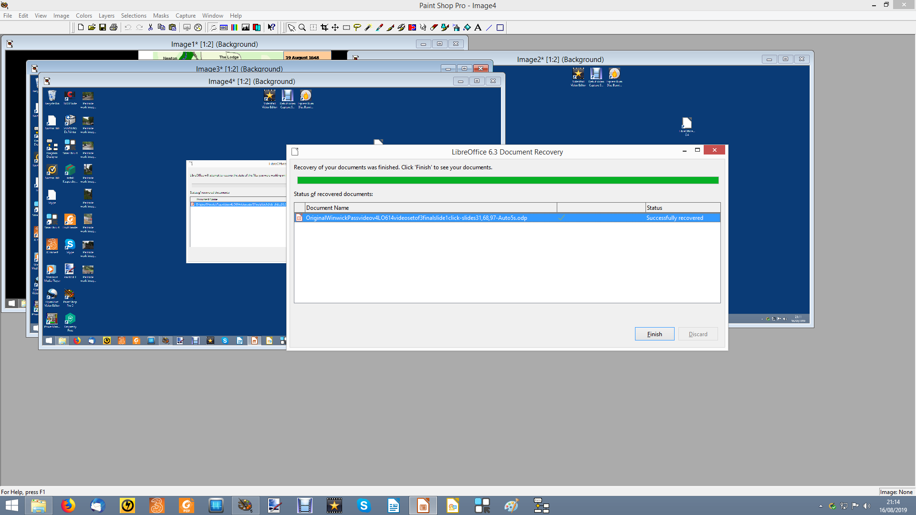

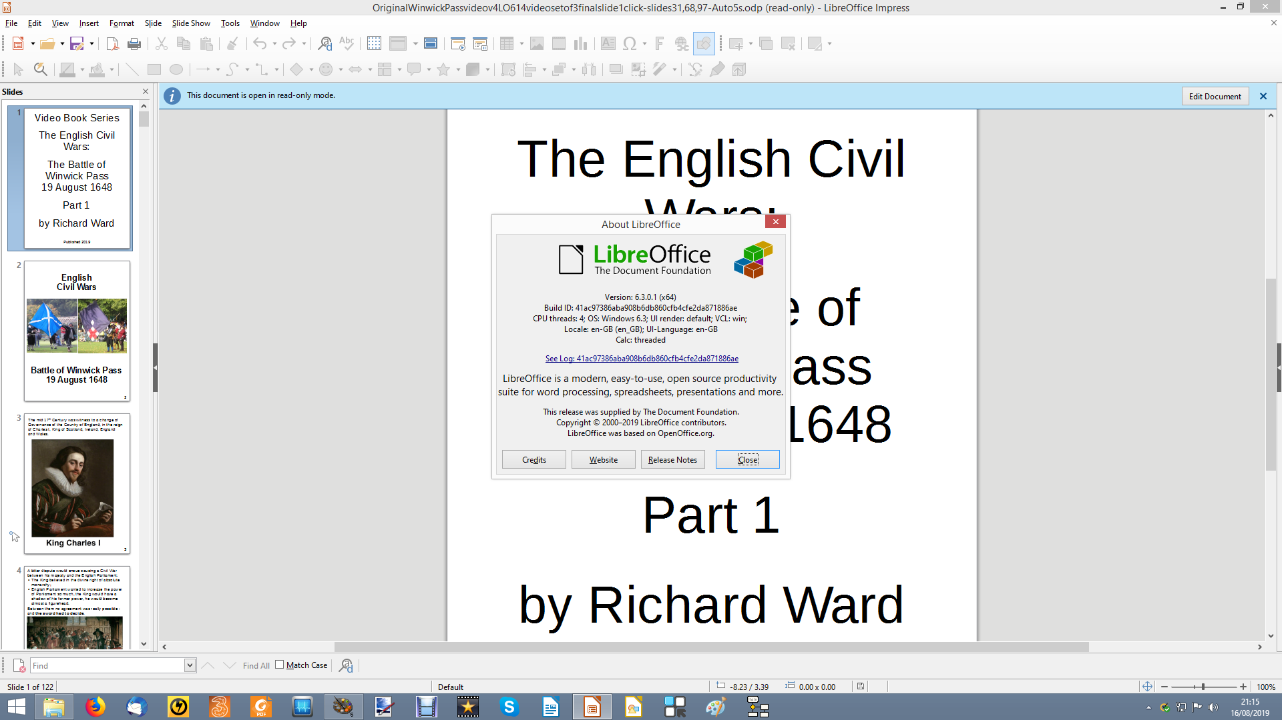

End

Now to repeat with LibreOffice 6.4 running on Windows 8.1 platform with File: OriginalWinwickPassvideov4LO614videosetof3finalslide1click-slides31,68,97-Auto5s.odp and running Slide show click slide 1 then let the presentation automatically run.
Stopped at slide 92 Lh mose click, jumped to slide 93 partial animation then stopped, LH mouse click twice, moved on to slide 94, then on to slide 95 where partial animation then stopped, LH mouse click numerous times – nothing. Then RH mouse click - LibreOffice dropped out to the main Windows screen.Re loading LibreOffice 6.4:
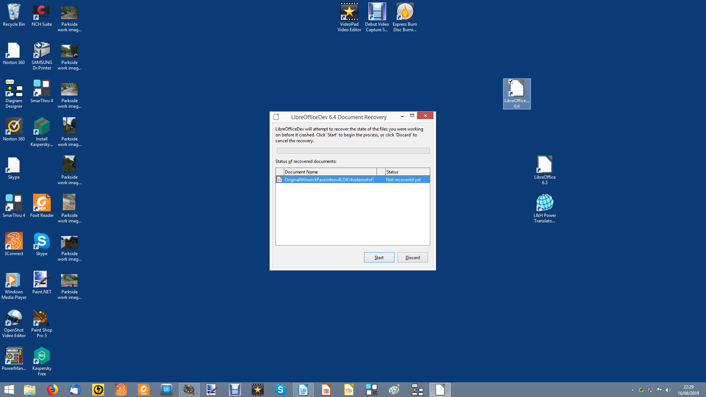
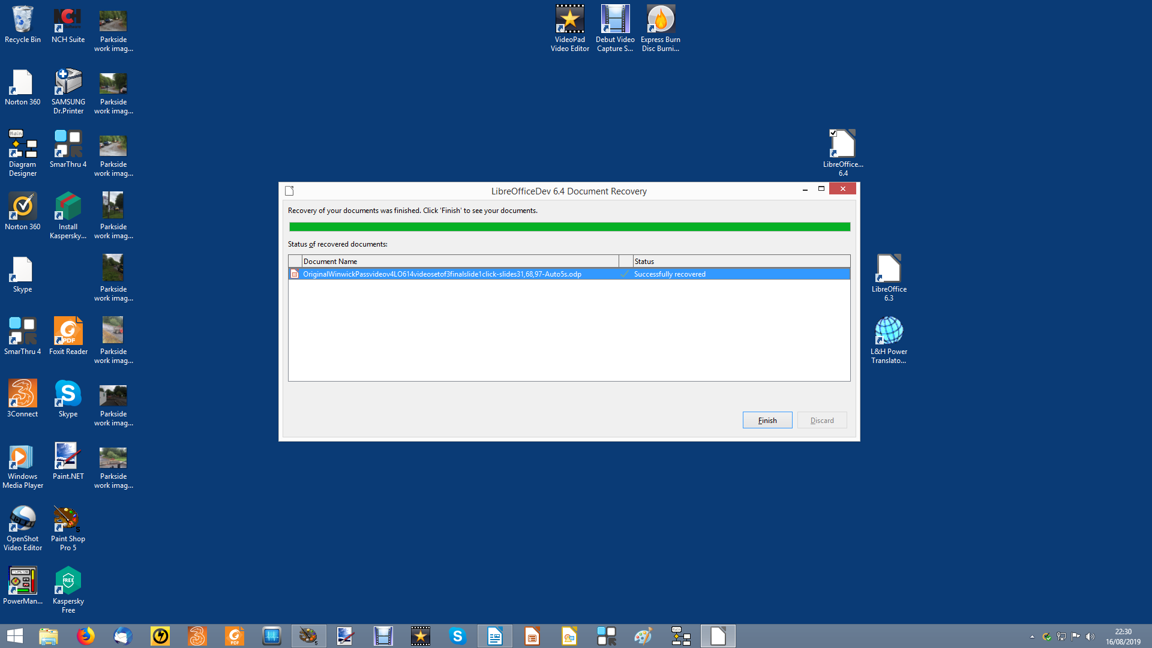

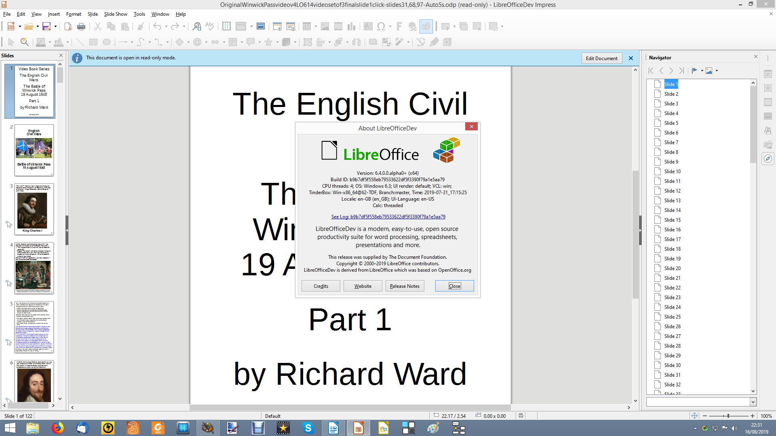

End

