Using Libre Office 6.3.0.1 (x64) New_Winwick_Pass.odp with slides 31, 68 and 97 corrected from advance slide by click of mouse to automatic advance by 5 seconds. File saved as New_Winwick_Pass slide1 click all the rest auto inc 31, 68 97.odp and properties changed to read only.

The slide show was started and progressed normally to slide 87 where show stopped with only the first two lines displayed and the rest of the text very very faint, moved mouse (no click) text appeard then continued on to slide 88 then on to slide 89. Slide 89 appeared for a long time – moved mouse (no click) no change. LH mouse click no advance of show; RH mouse click – the box that normally shows options: previous/next/end, but shows a white box. Clicking LH or RH mouse screen does not respond. Then the RH Click shows the previous/next/end box, click end show closes, then the following error appears:
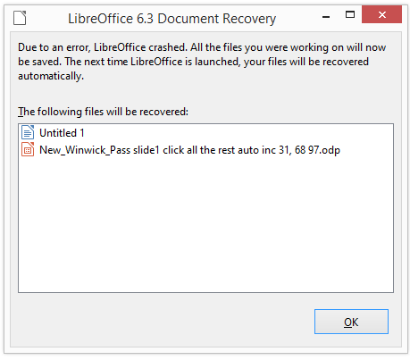
click OK then:
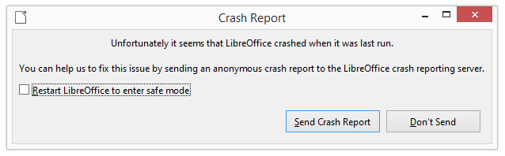
send crash report then:
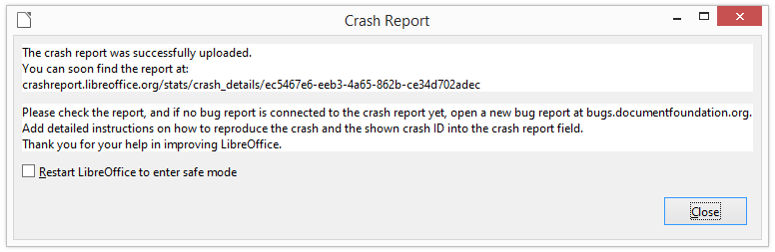
close box then document recovery appears:
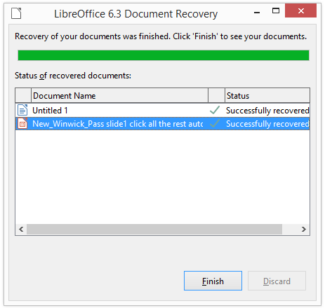
Click finish LibreOffice loads as normal.

