Here is a frame which contains two frames. One of the inside frames is a no-fill frame, the other is 100% transparent. They should both look the same…
Frame with area set to Black, 50% transparent
Frame with area set to “None”
anchored to paragraph of outside frame
Frame with area set to Black, 100% transparent
anchored to paragraph of outside frame

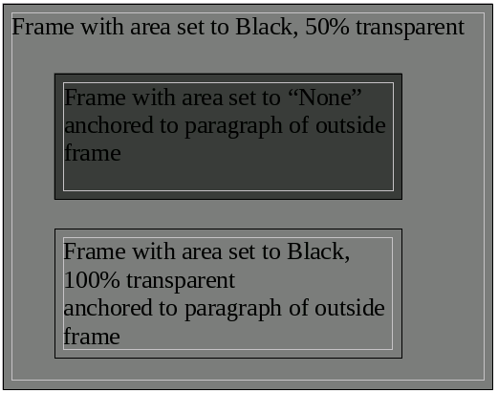
This is a screenshot of what the above frame situation looks like in my test environment (64bit Fedora 21, LibreOffice 5.0.3.2)

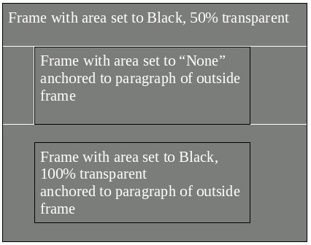

This is a screenshot of the exact same situation in LibreOffice 4.3. Both frames have the same level of transparency, as expected. You'll also notice that it suffers from the dreaded “nested frame transparency bug” and the automatic color actually still worked properly for transparent frames.

